User Interface Design

User Interface Design

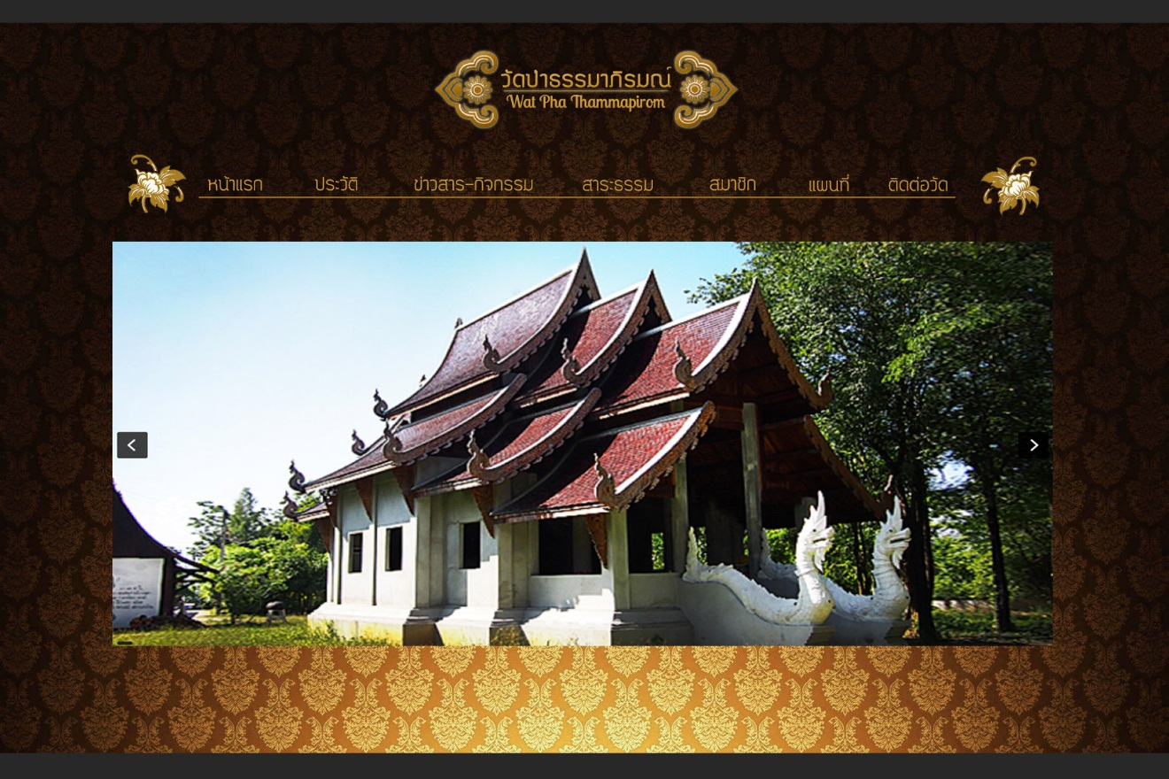

Figure UI-01 : User interface for Temple Index page of Guest

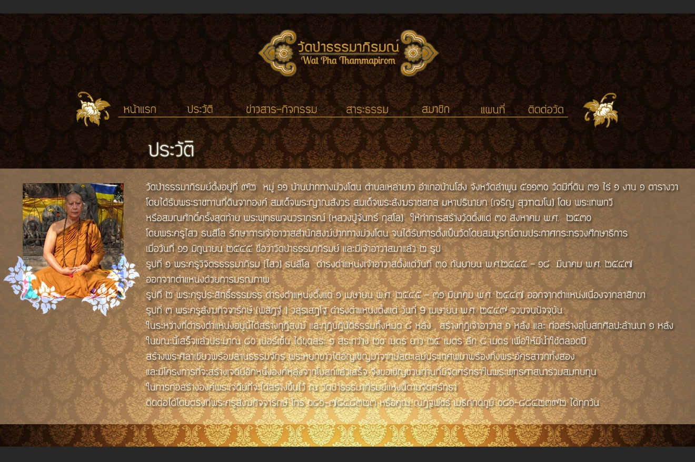

Figure UI-02 : User interface for Background page of Guest

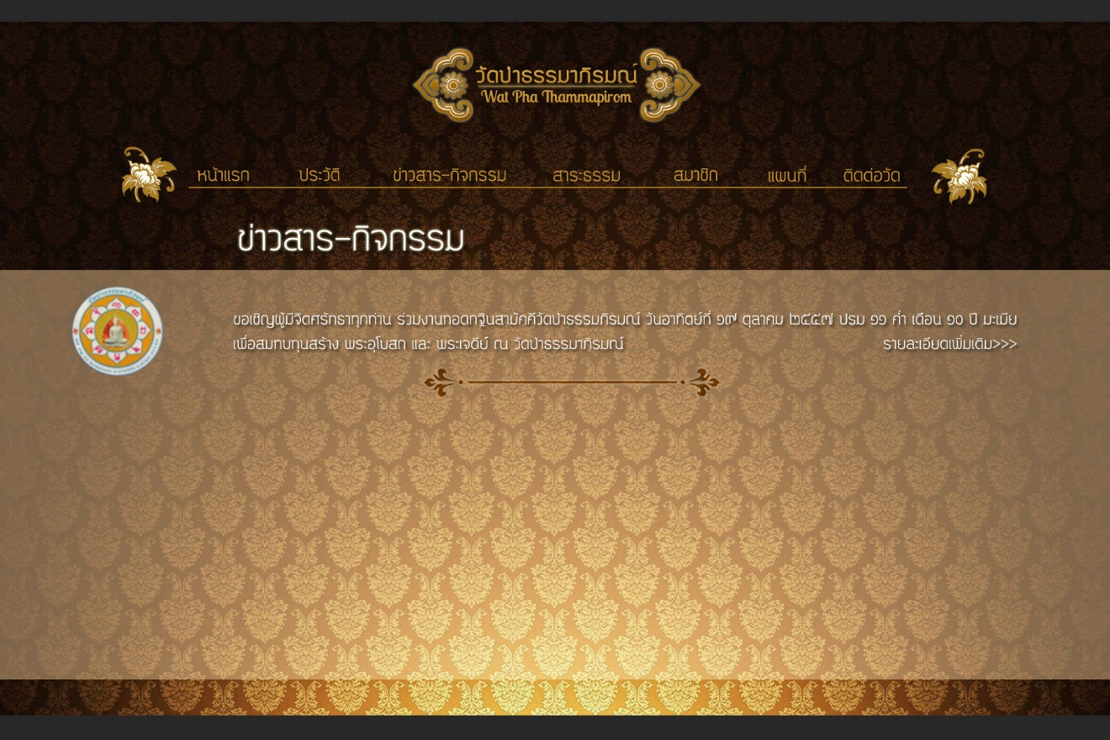

Figure UI-03 : User interface for News and Activities page of Guest

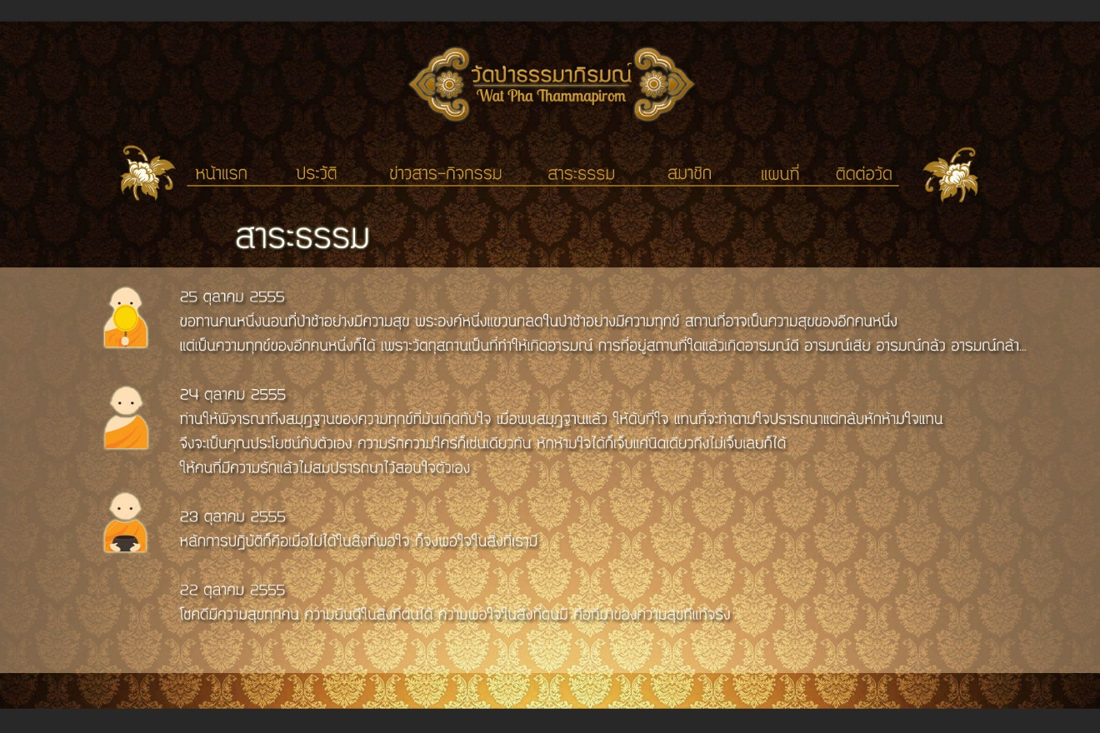

Figure UI-04 : User interface for Dhamma Content page of Guest

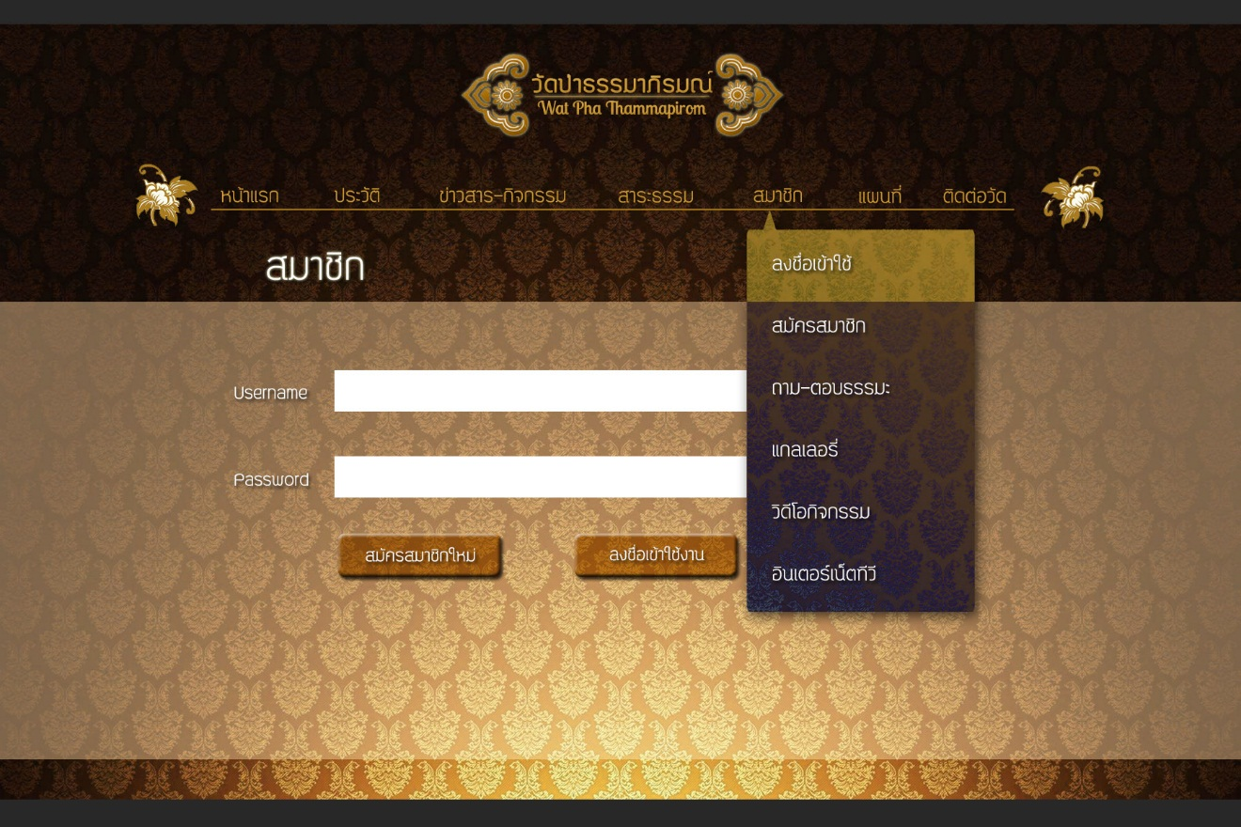

Figure UI-05 : User interface for Sign in page of Guest

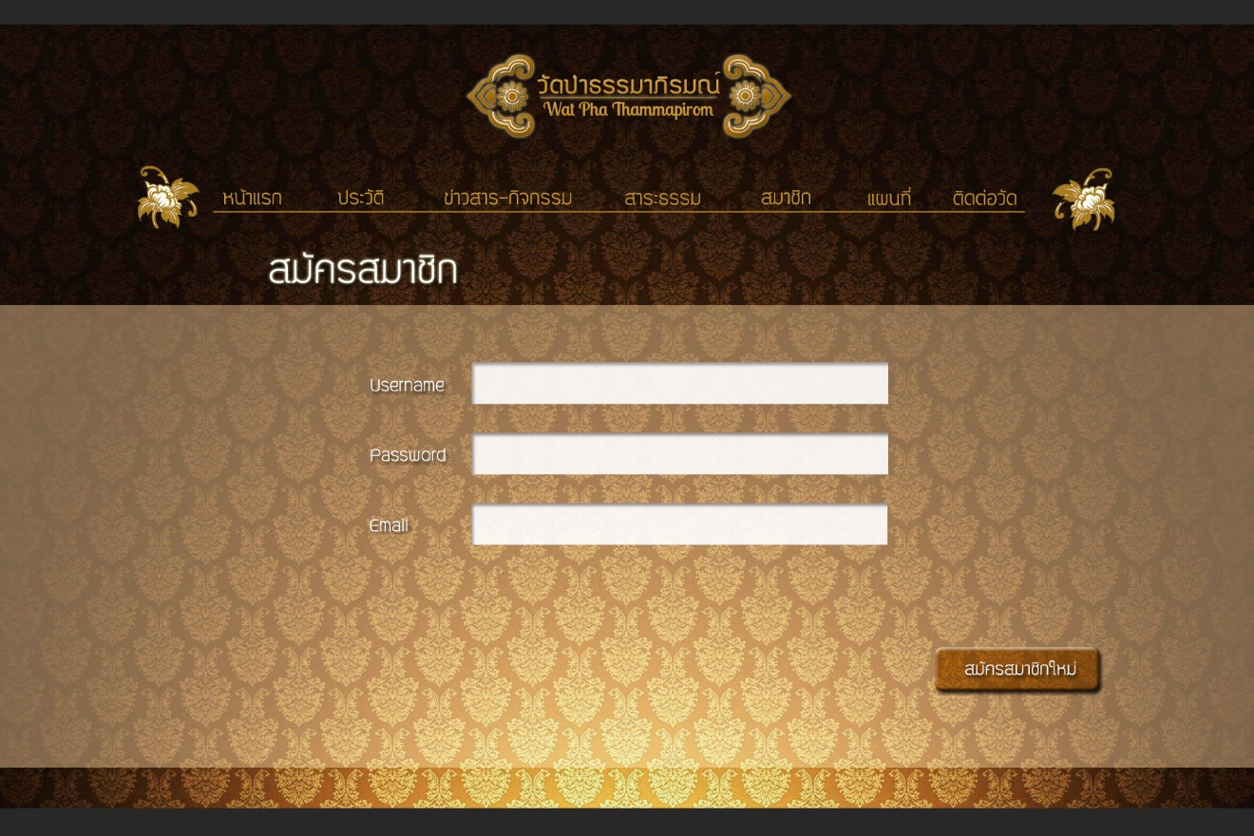

Figure UI-06 : User interface for Register page of Guest

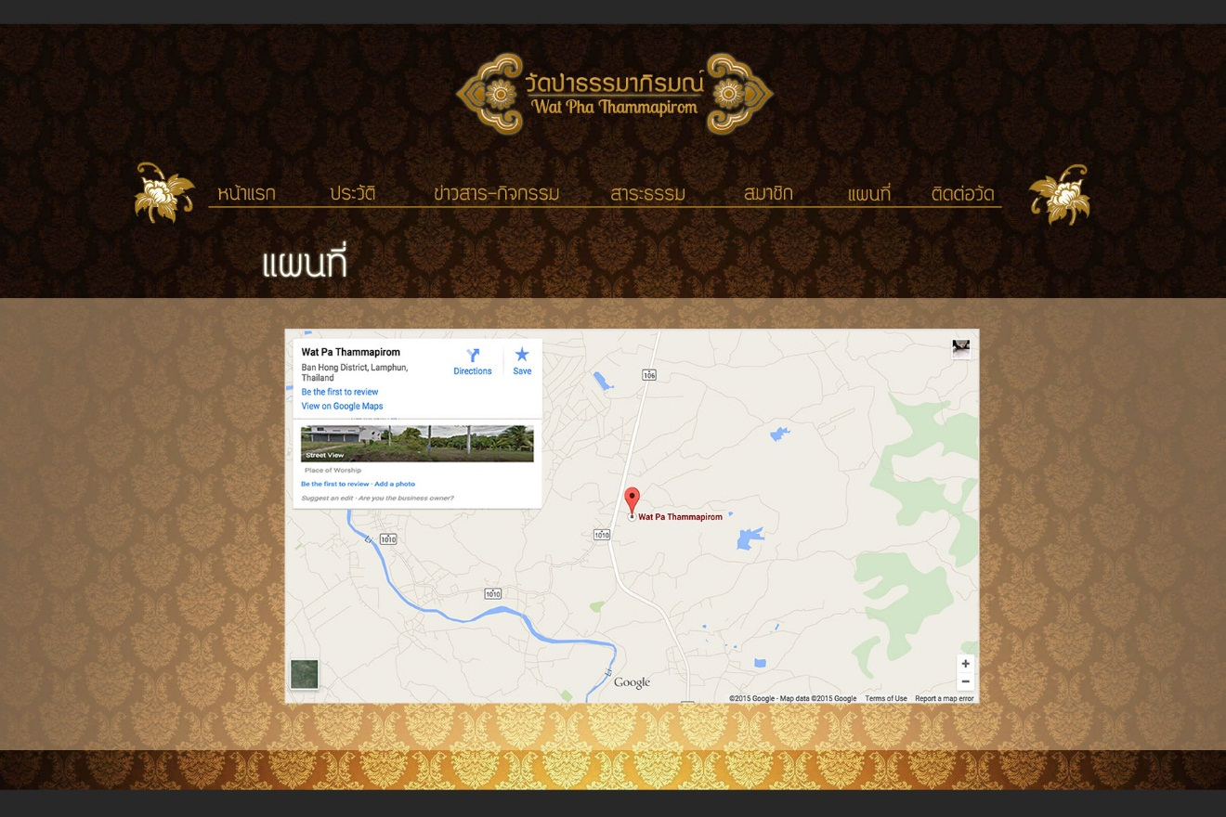

Figure UI-07 : User interface for Temple Map page of Guest

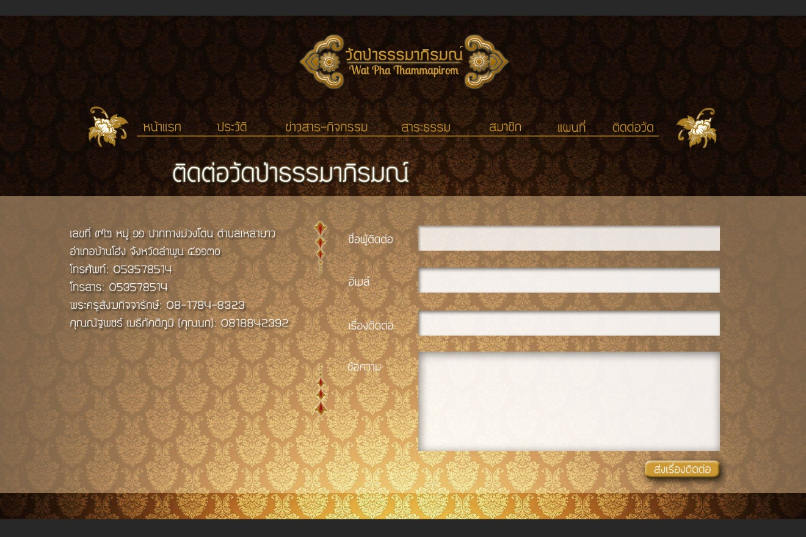

Figure UI-08 : User interface for Temple Contact page of Guest

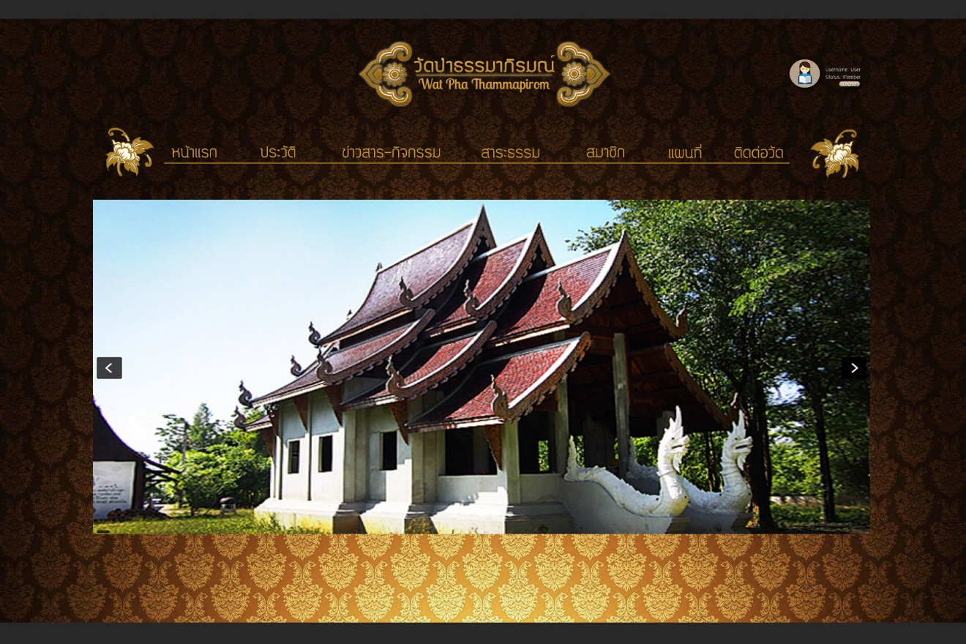

Figure UI-09 : User interface for Index page of Member

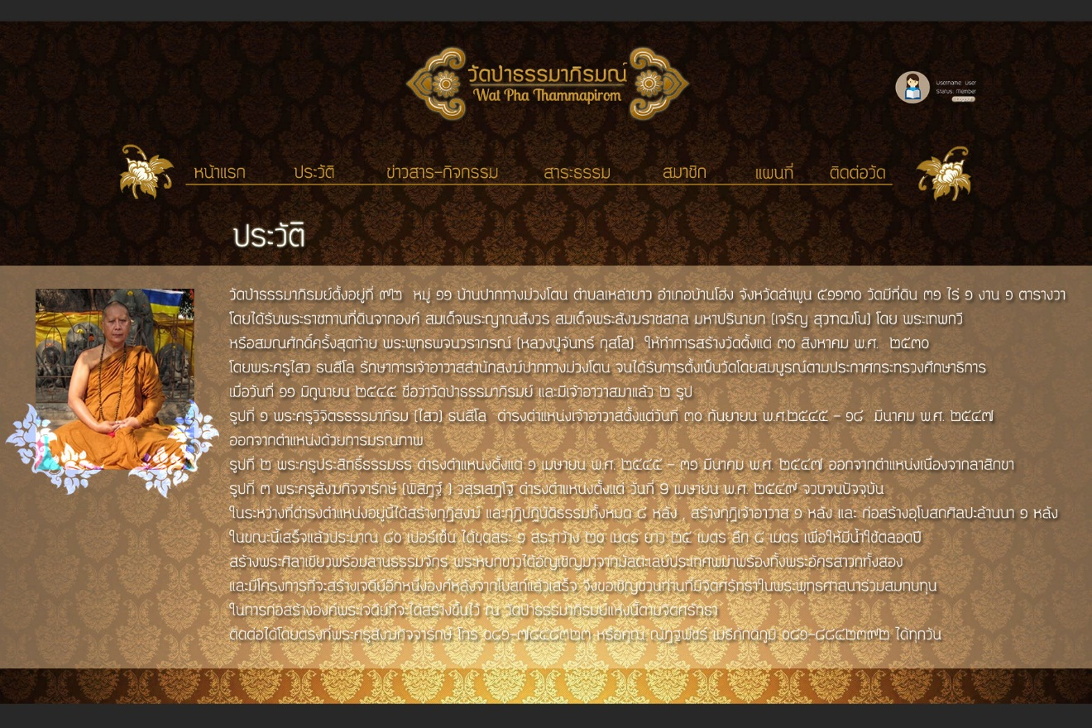

Figure UI-10 : User interface for Background page of Member

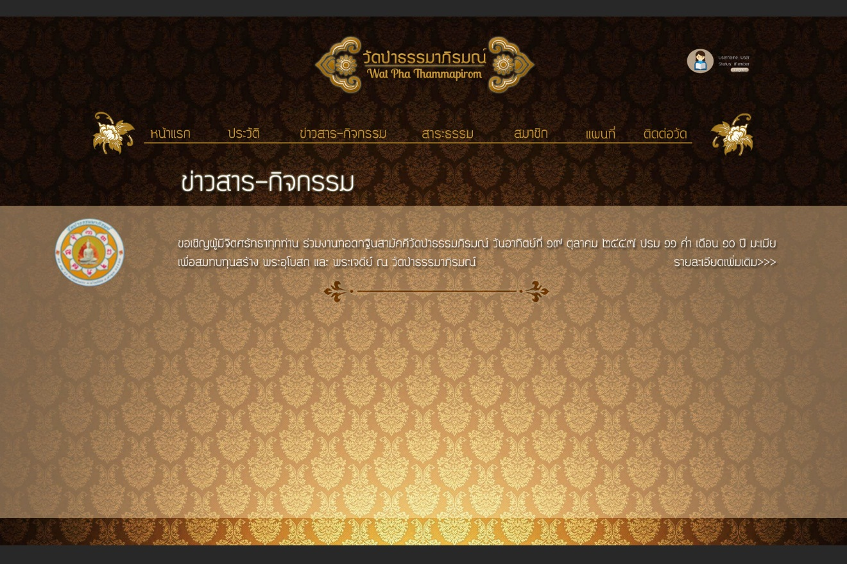

Figure UI-11 : User interface for News and Activities page of Member

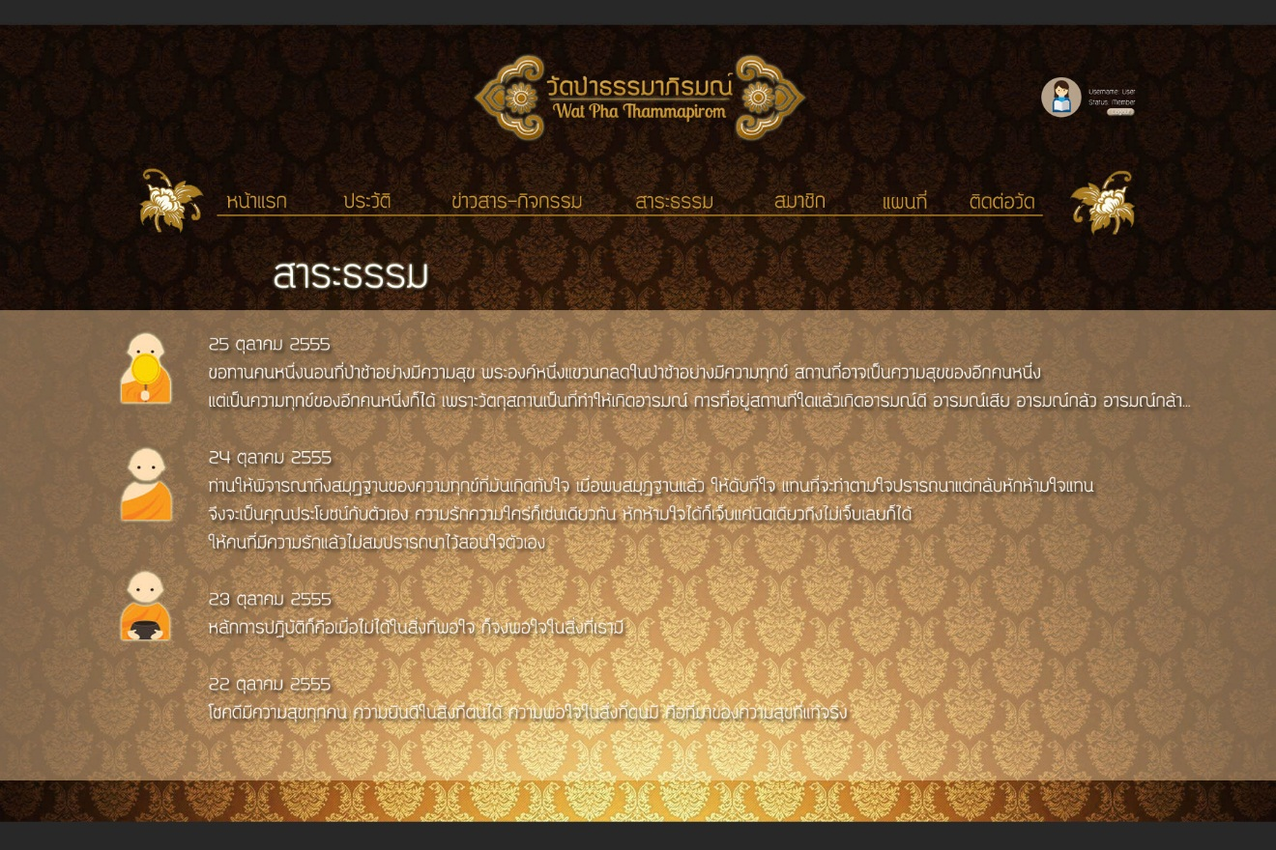

Figure UI-12 : User interface for Dhamma page of Member

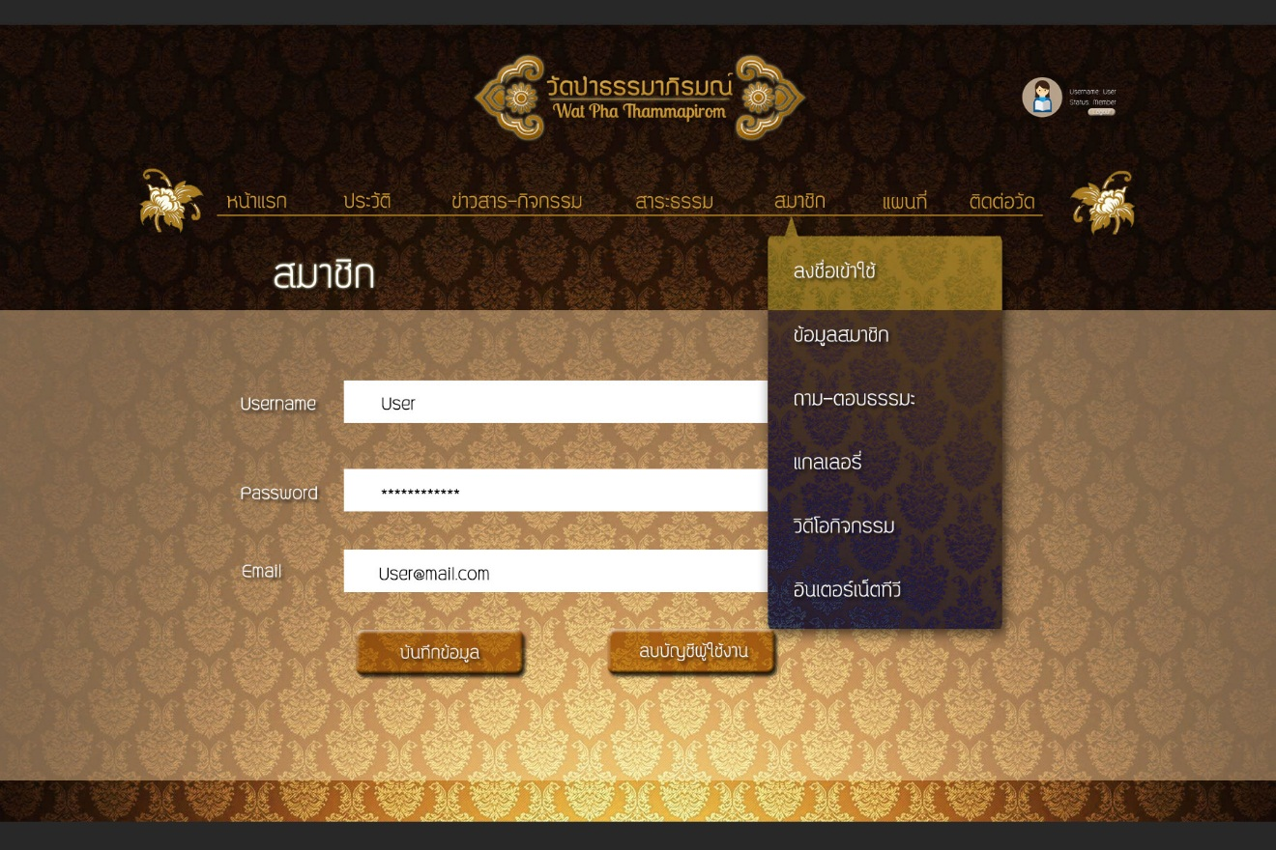

Figure UI-13 : User interface for Sign in page of Member

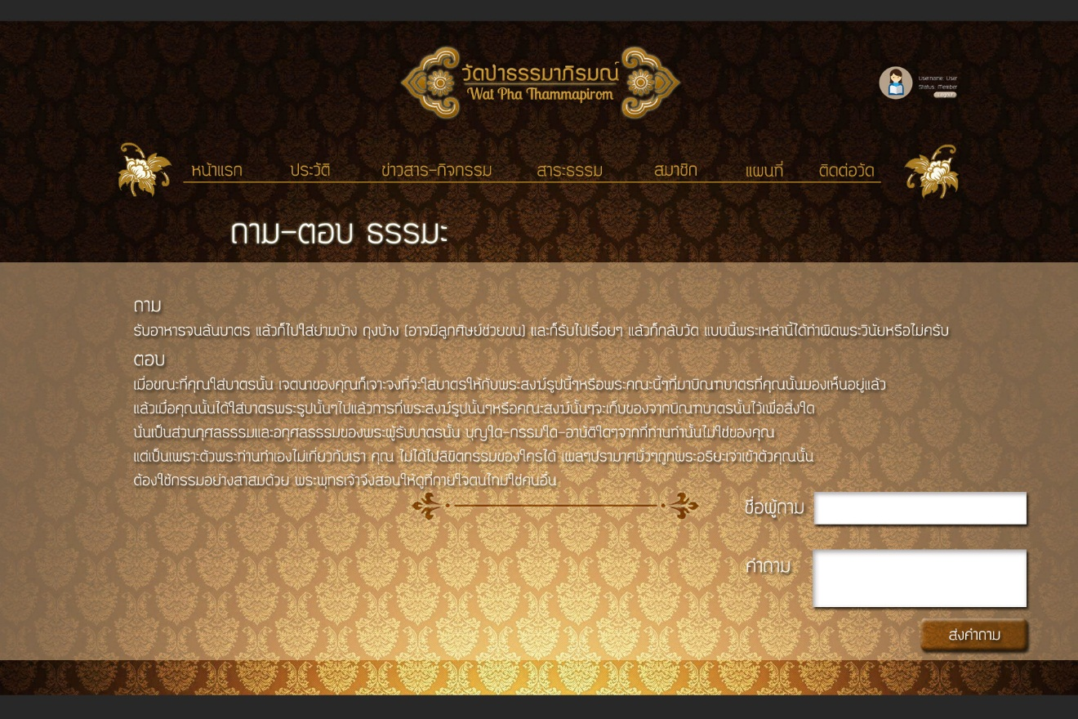

Figure UI-14 : User interface for Dhamma Contact Topic page of Member

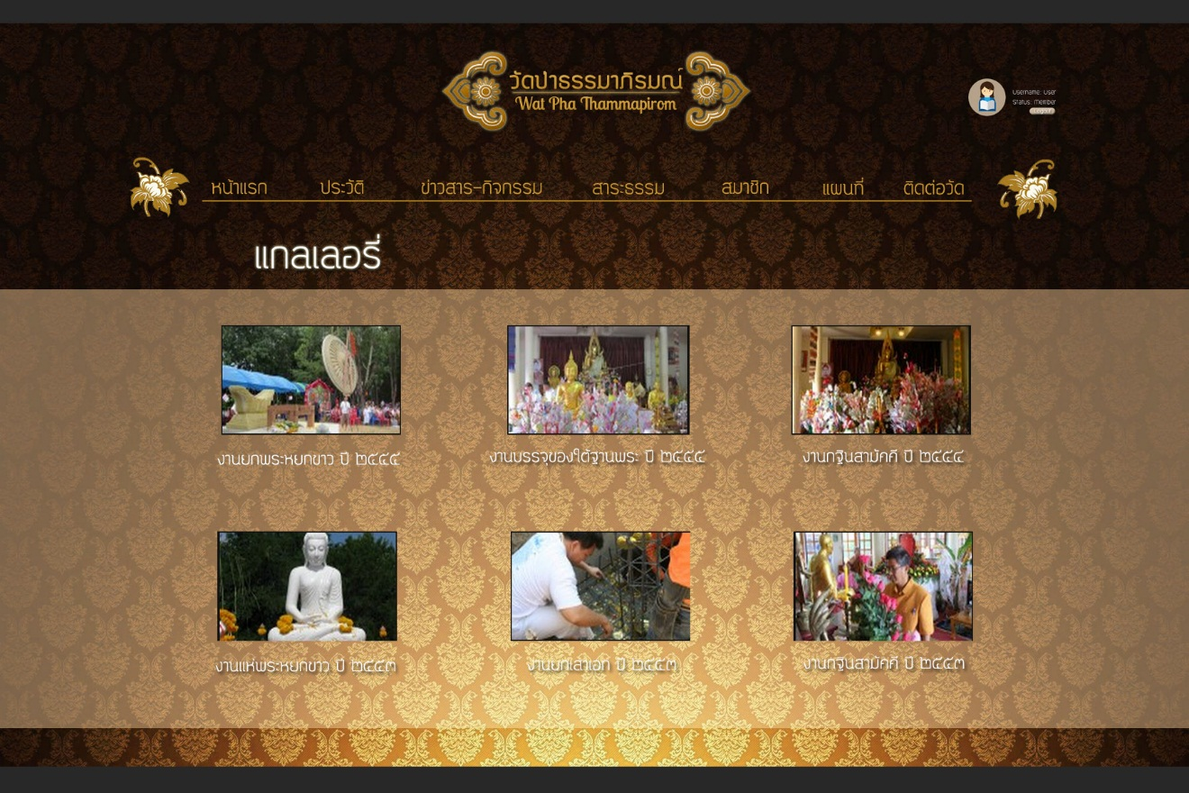

Figure UI-15 : User interface for Gallery page of Member

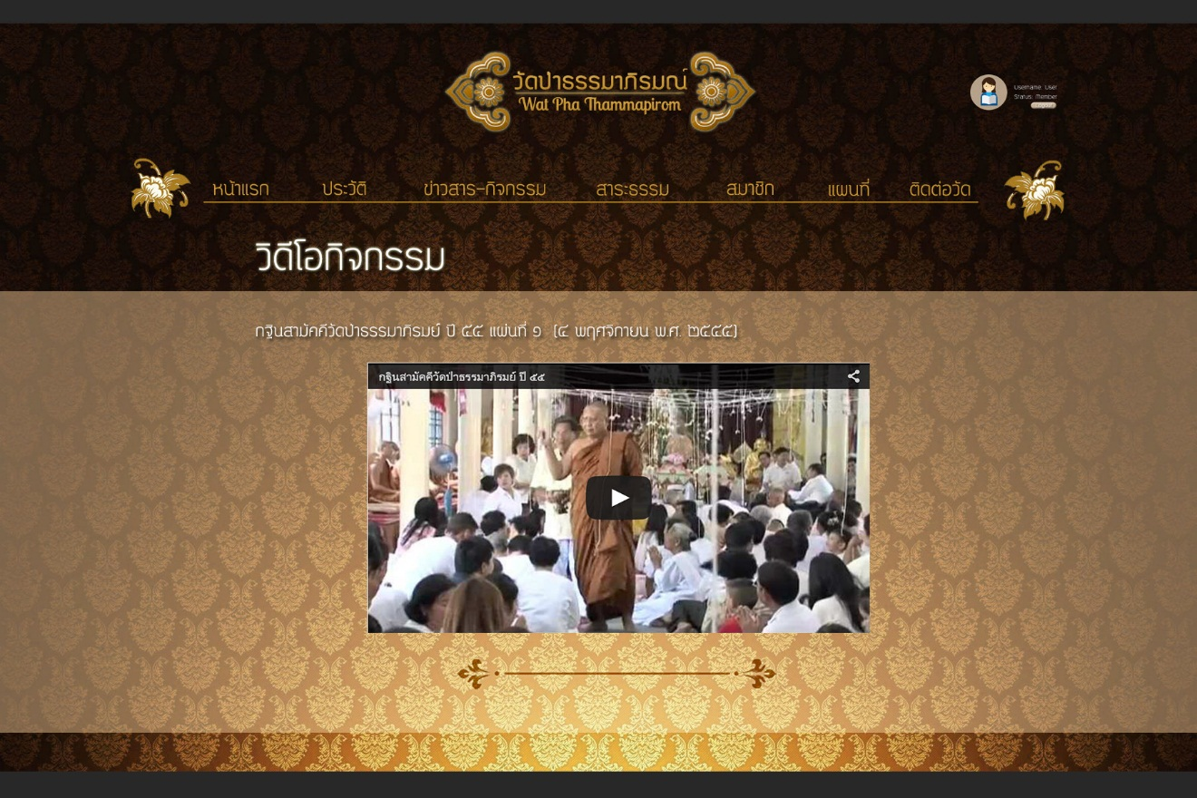

Figure UI-16 : User interface for Activities Video Clips page of Member

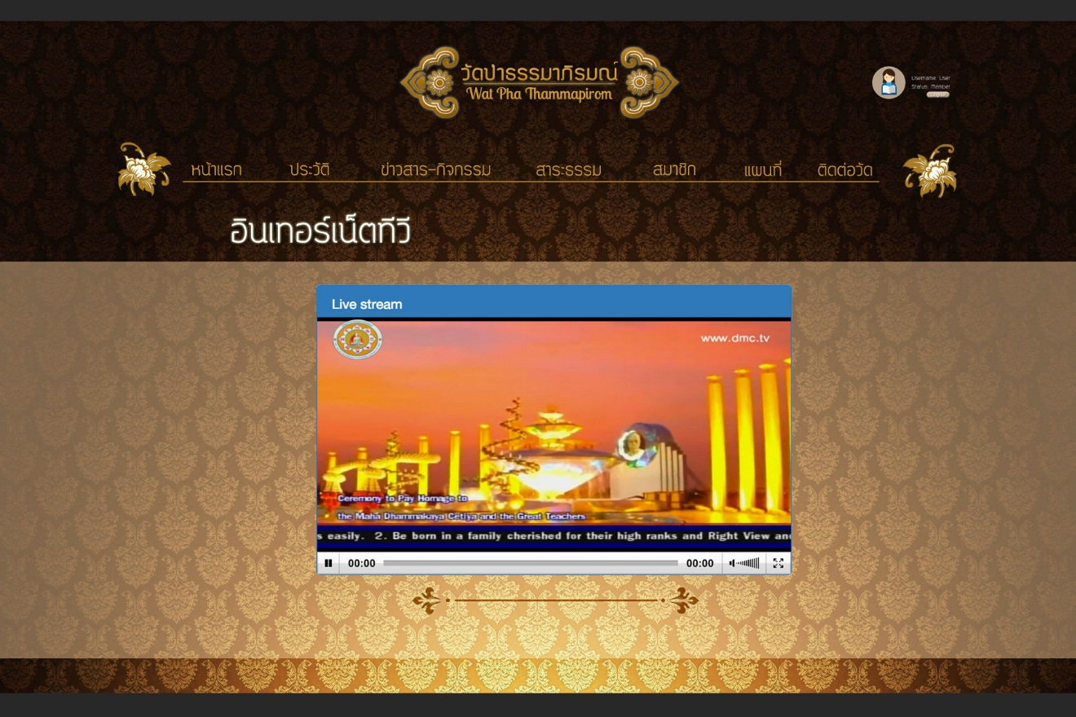

Figure UI-17 : User interface for Internet TV page of Member

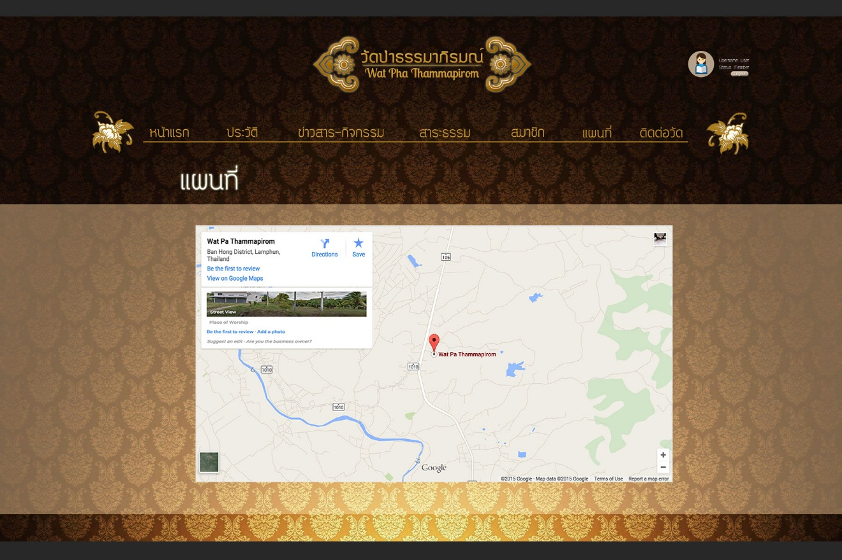

Figure UI-18 : User interface for Temple Map page of Member

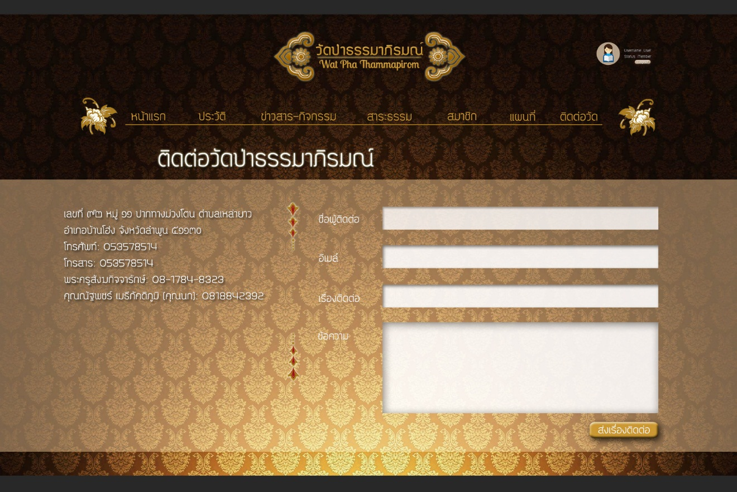

Figure UI-19 : User interface for Temple Contact page of Member

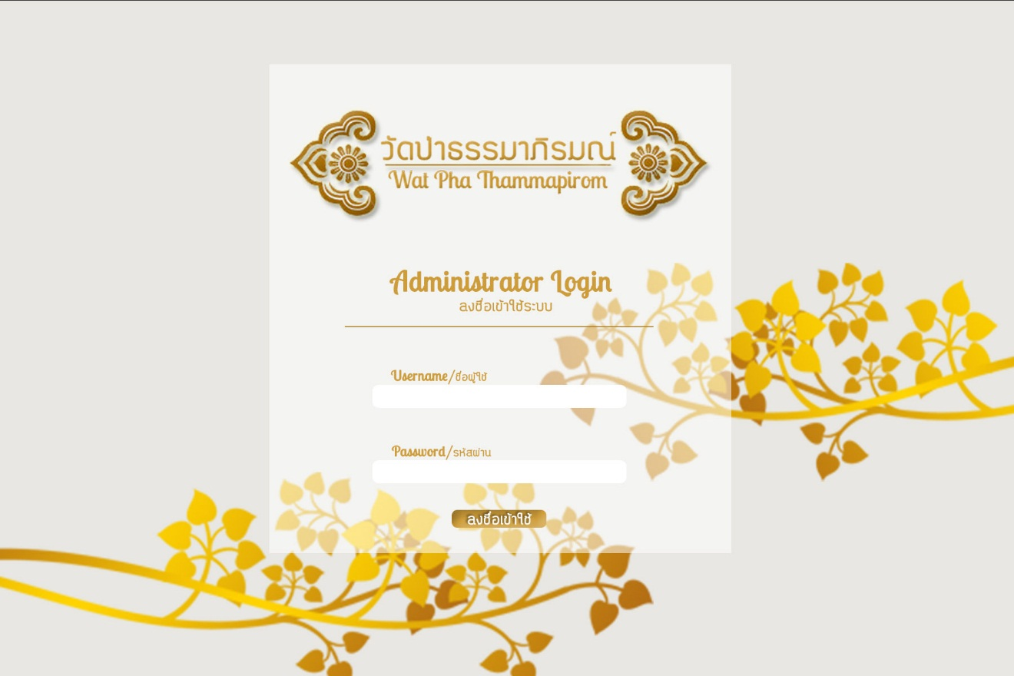

Figure UI-20 : User interface for Sign in page of Administer

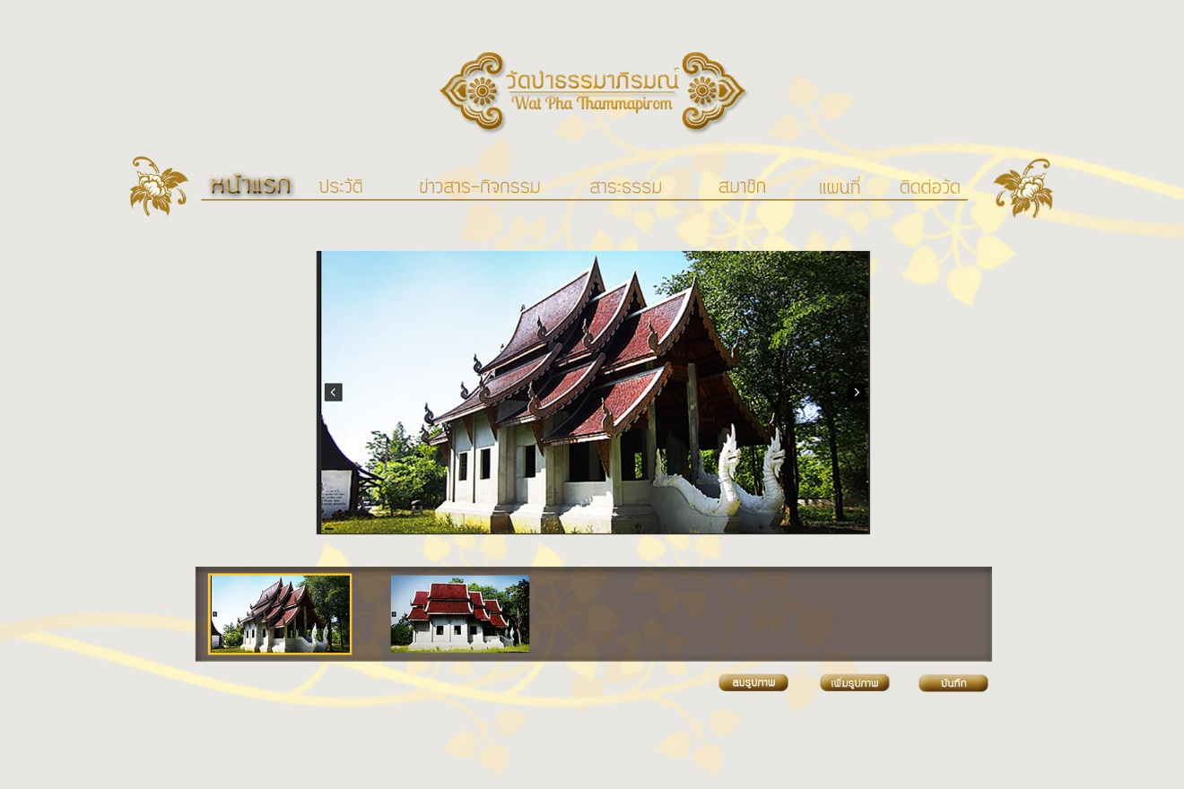

Figure UI-21 : User interface for Index page of Administer

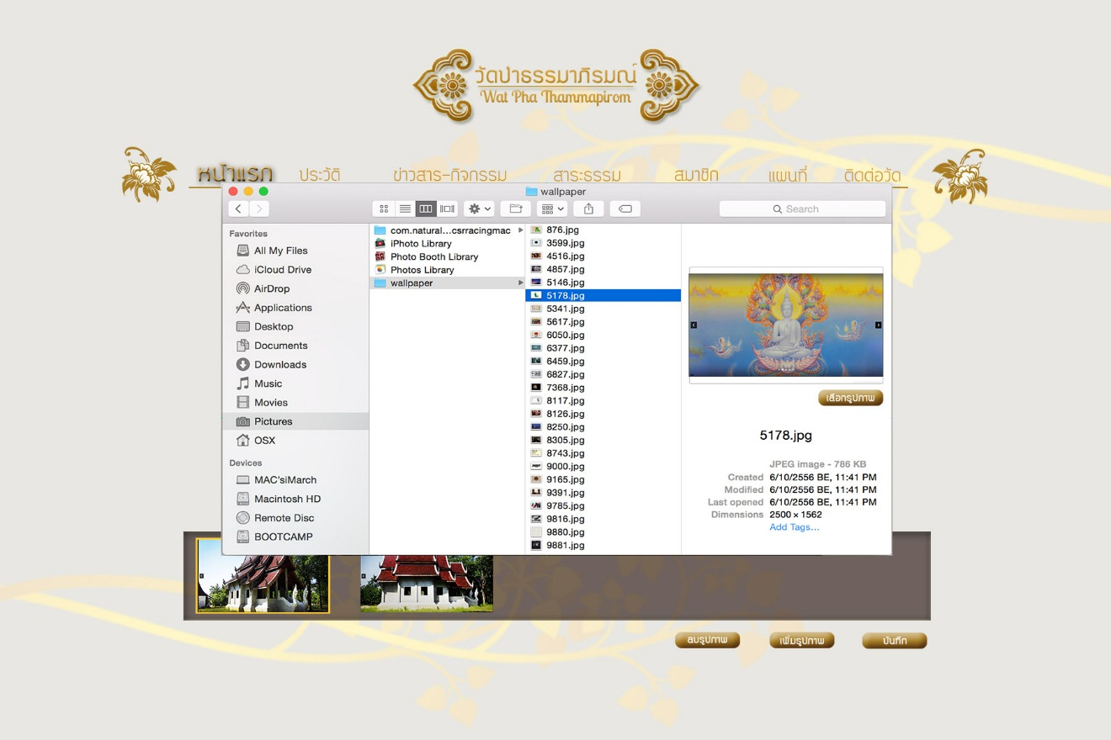

Figure UI-22 : User interface for Add new image page of Administer

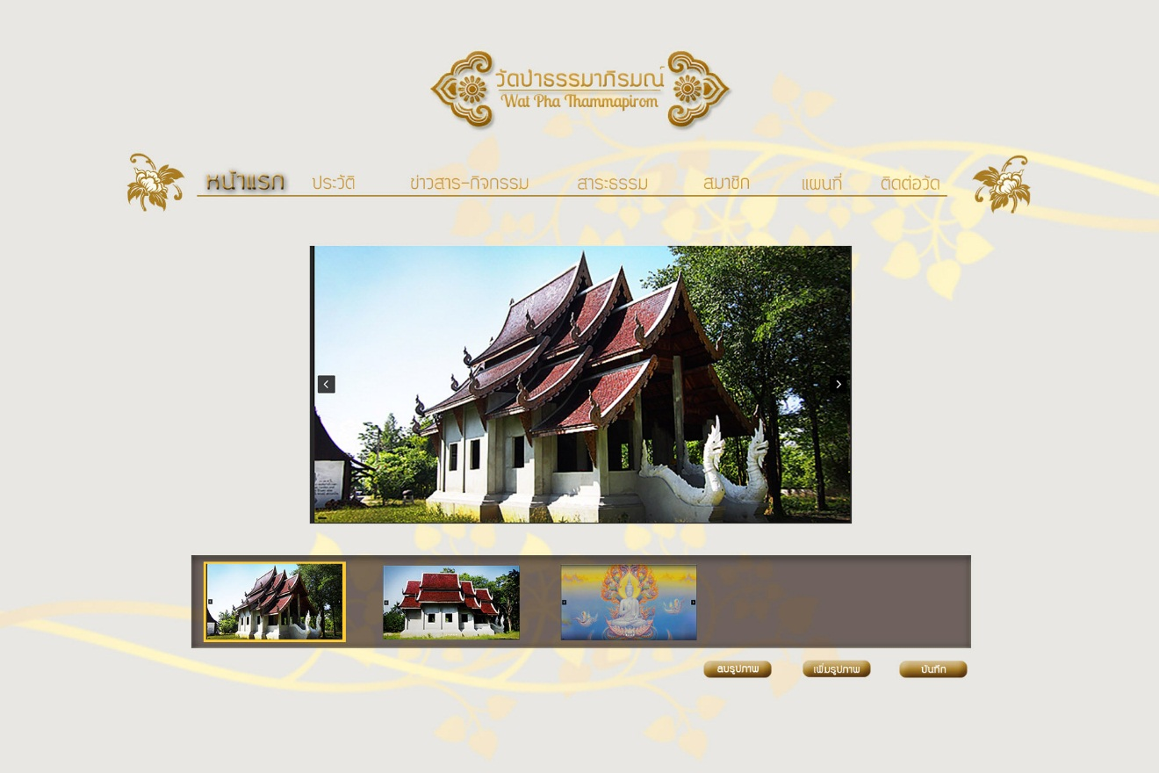

Figure UI-23 : User interface for Choose delete image page of Administer

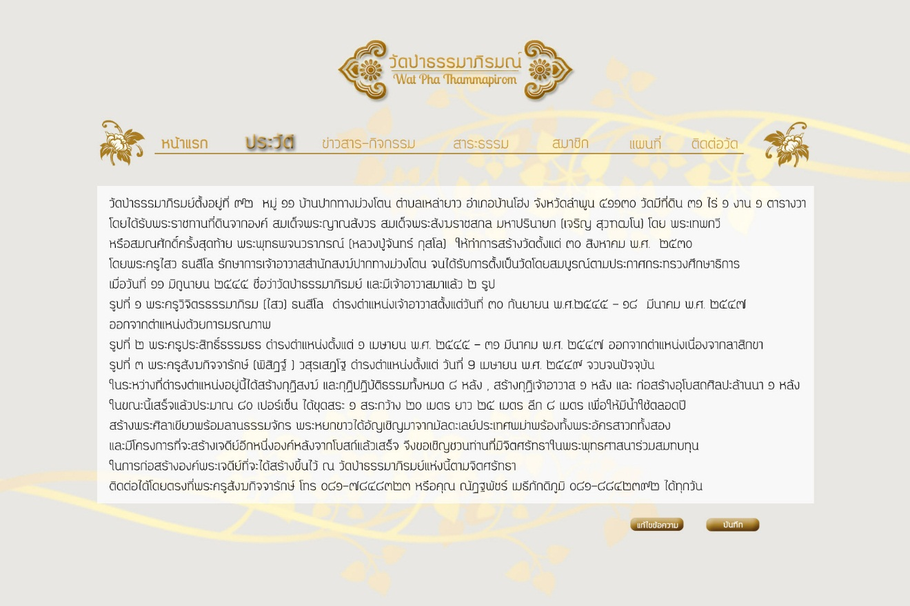

Figure UI-24 : User interface for Background page of Administer

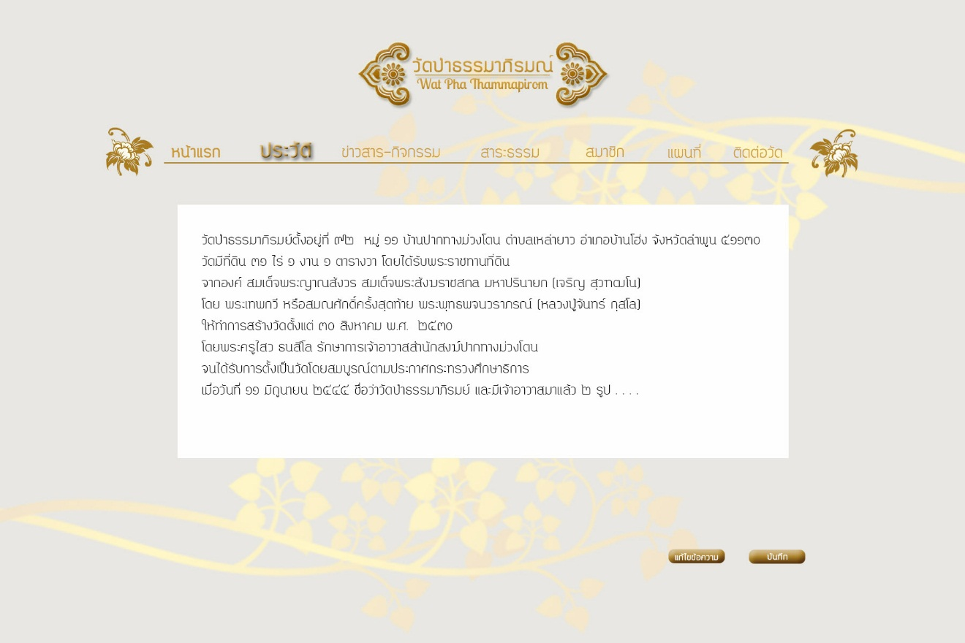

Figure UI-25 : User interface for Edit Background page of Administer

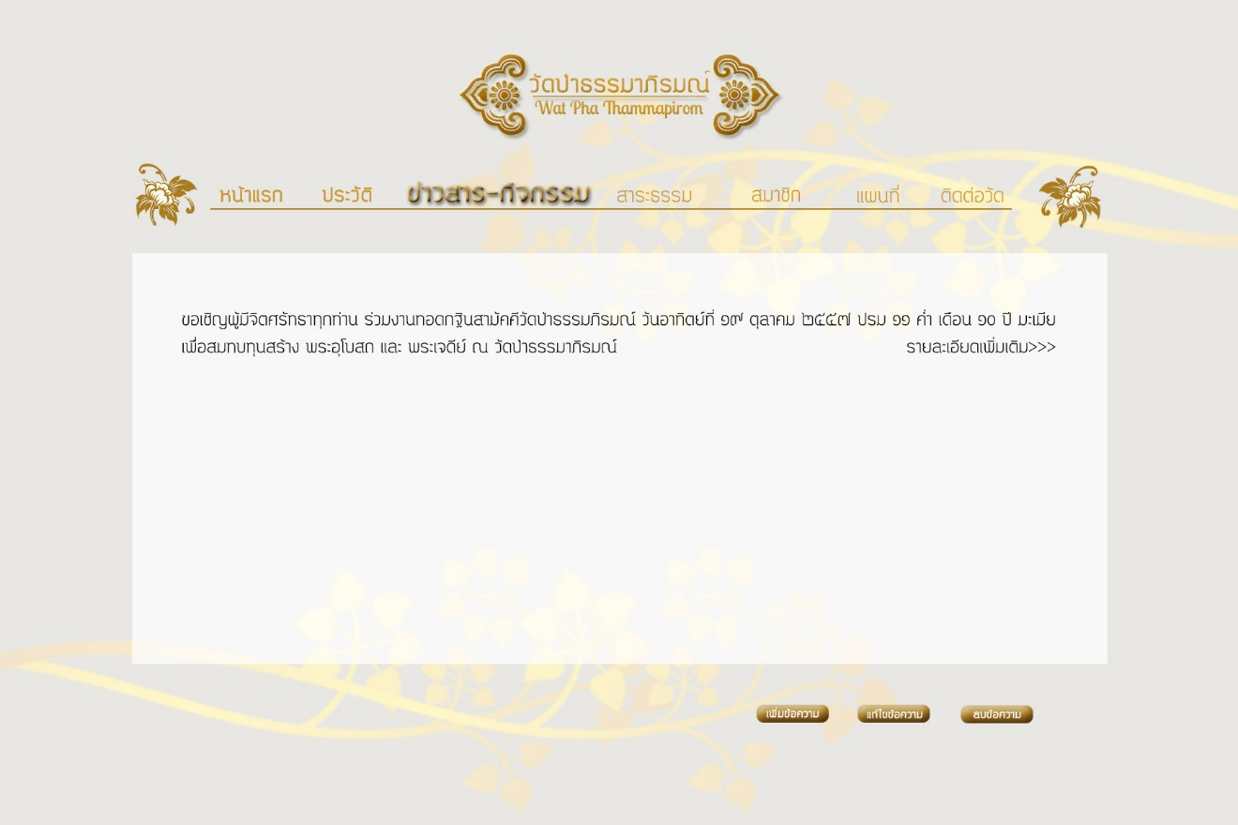

Figure UI-26 : User interface for News and Activities page of Administer

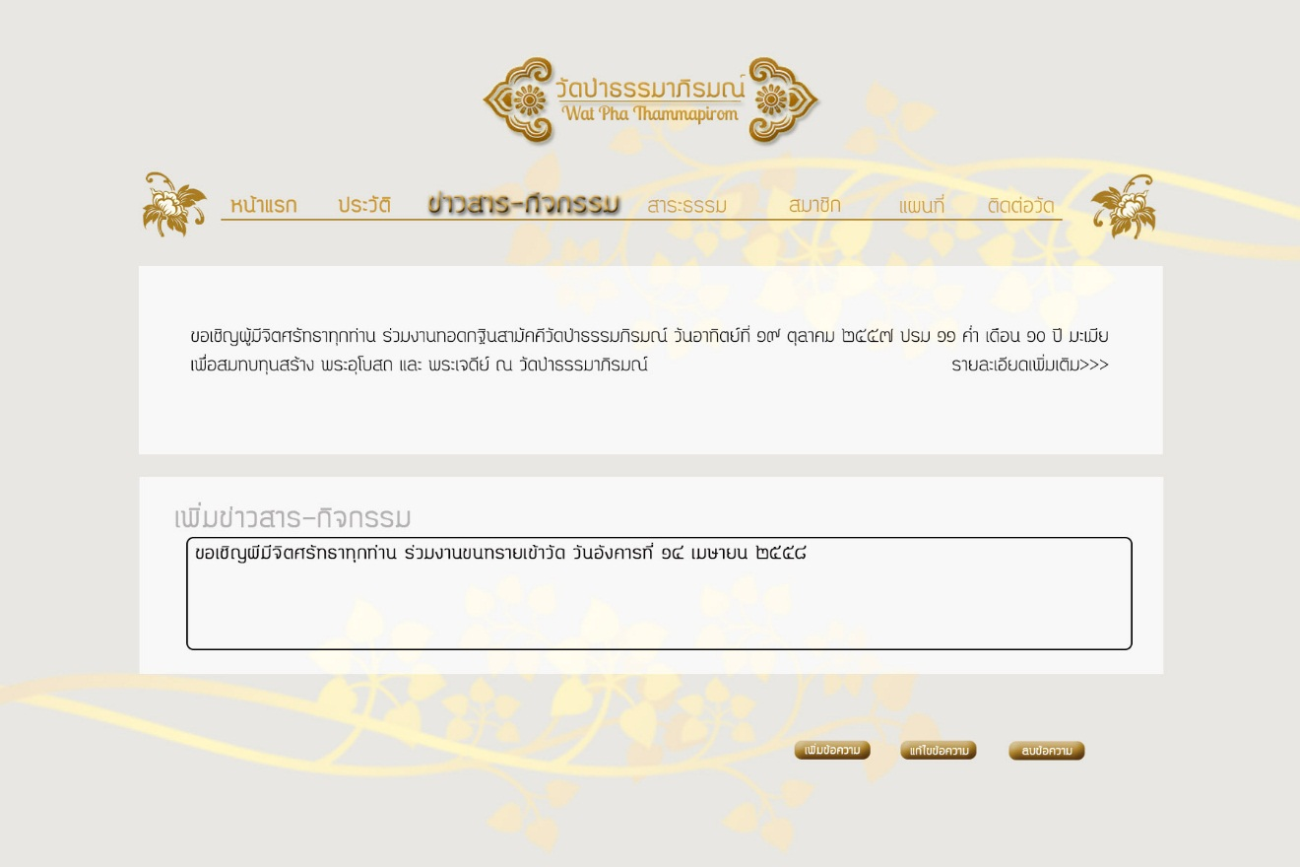

Figure UI-27 : User interface for Add News and Activities page of Administer

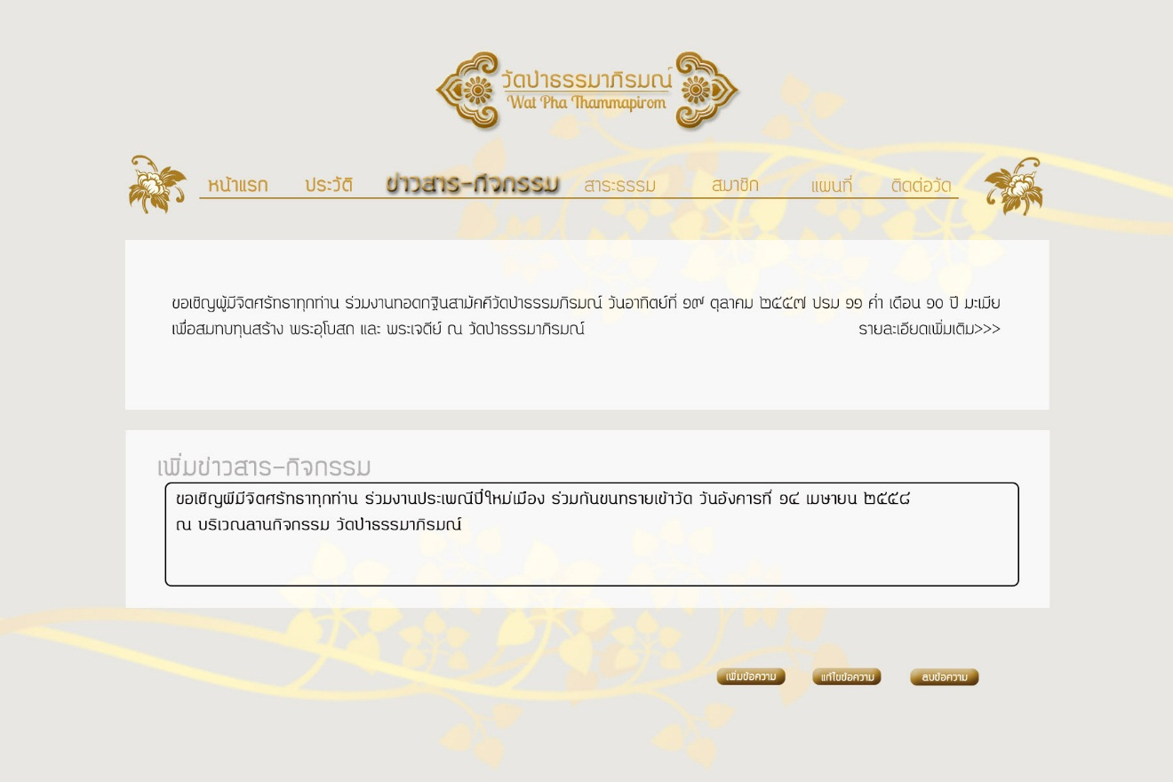

Figure UI-28 : User interface for Edit News and Activities page of Administer

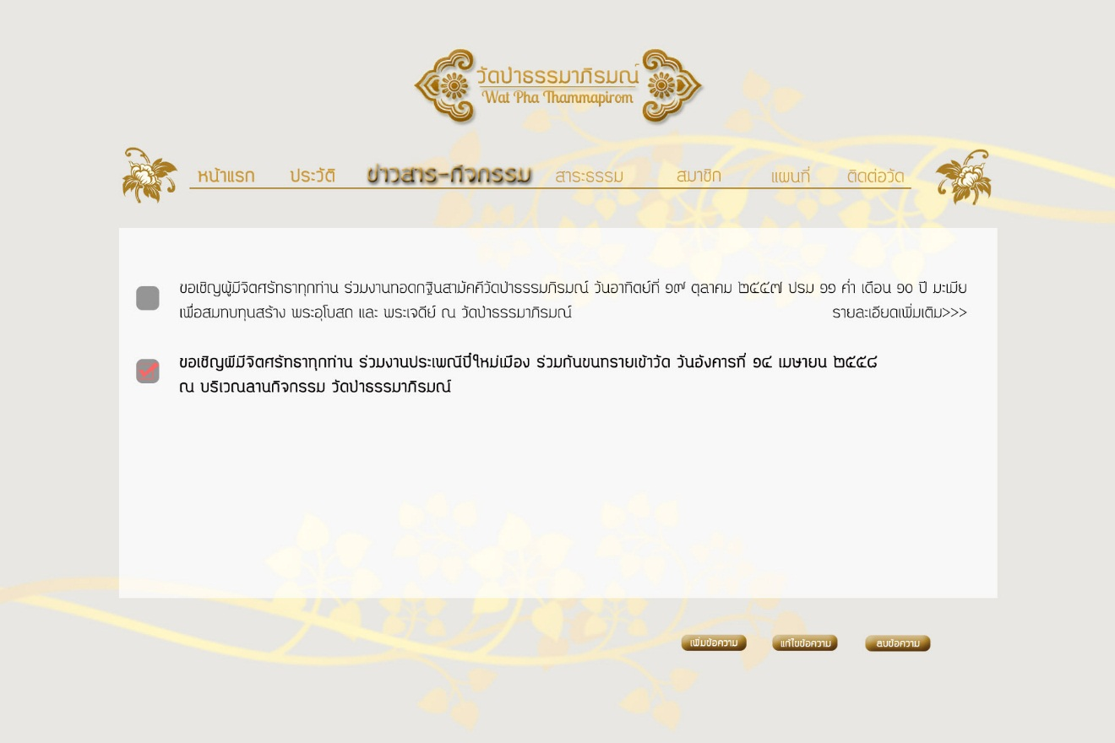

Figure UI-29 : User interface for Delete News and Activities page of Administer

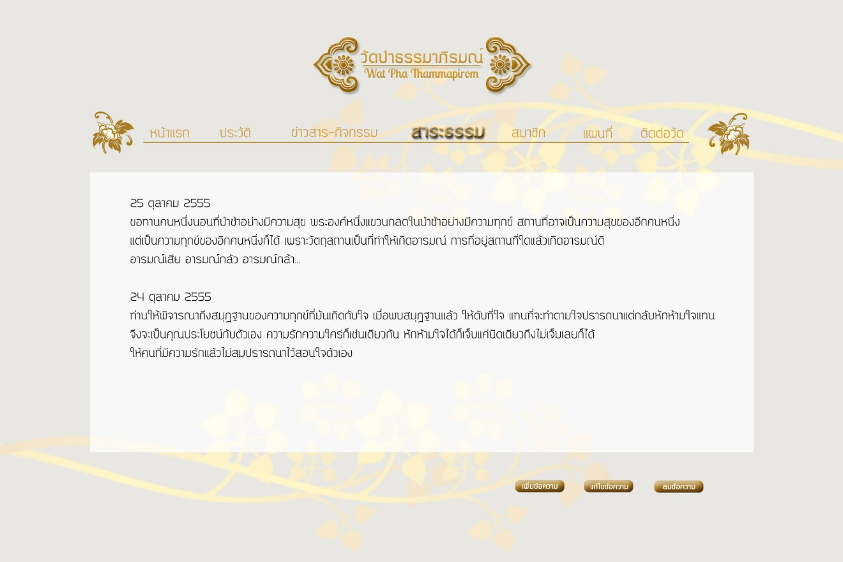

Figure UI-30 : User interface for Dhamma page of Administer

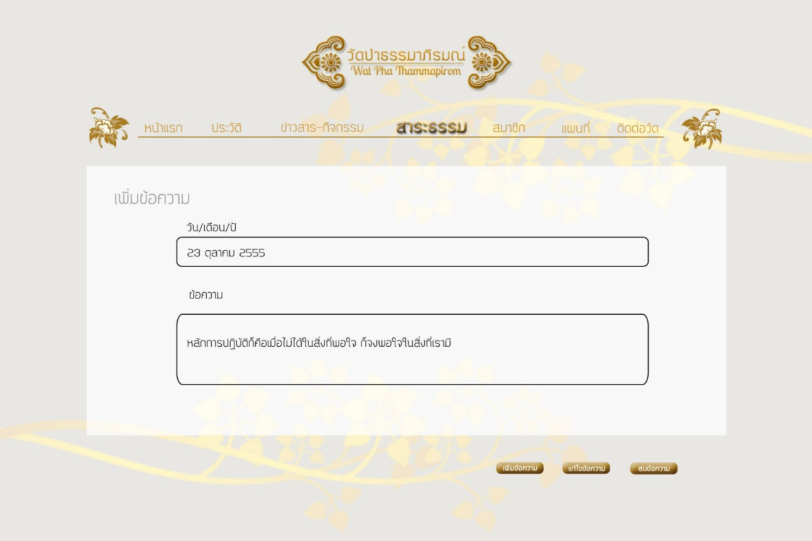

Figure UI-31 : User interface for Add new Dhamma page of Administer

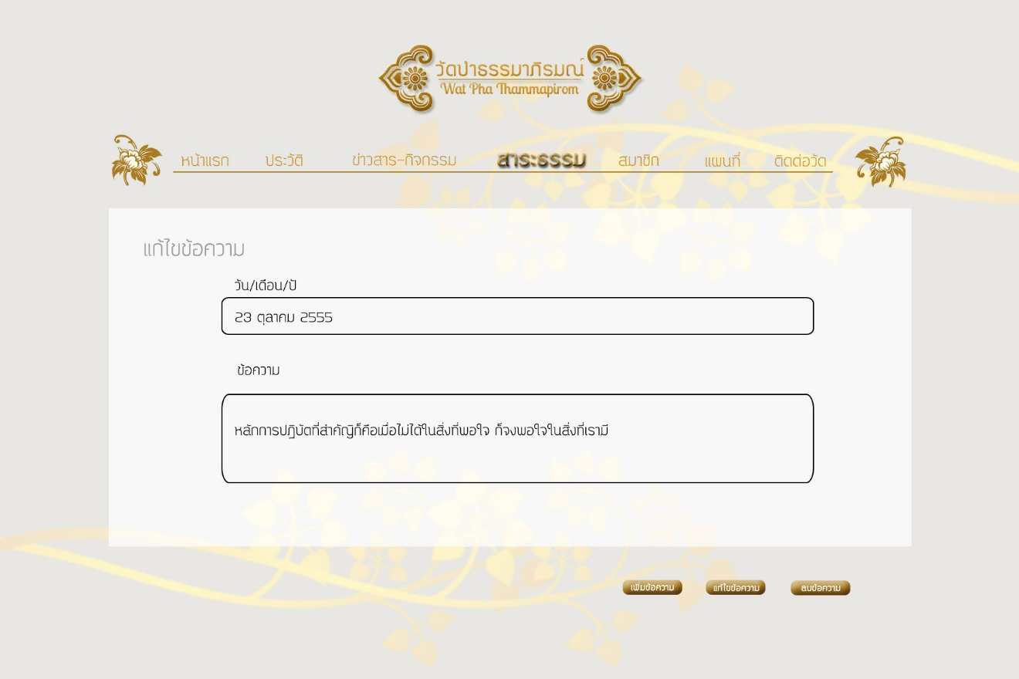

Figure UI-32 : User interface for Edit Dhamma page of Administer

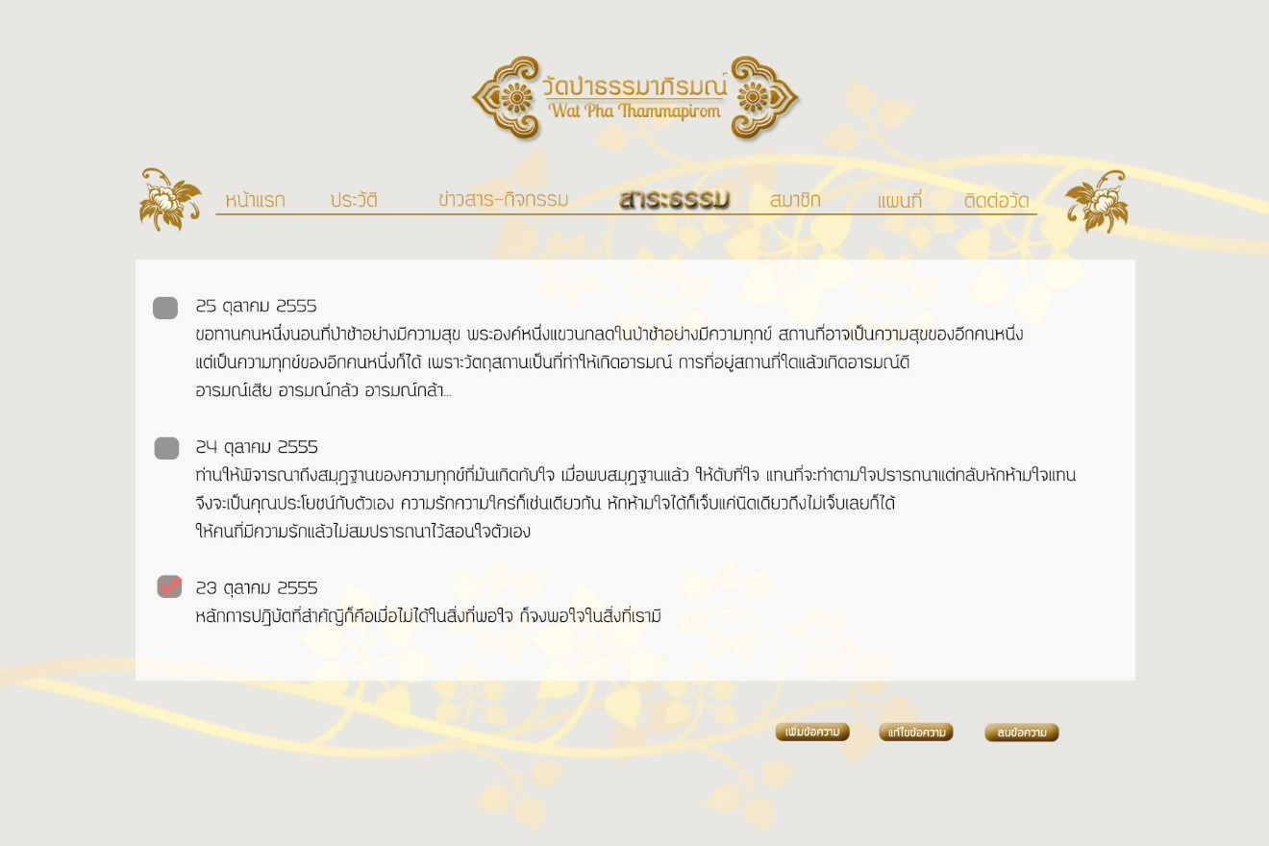

Figure UI-33 : User interface for Delete Dhamma page of Administer

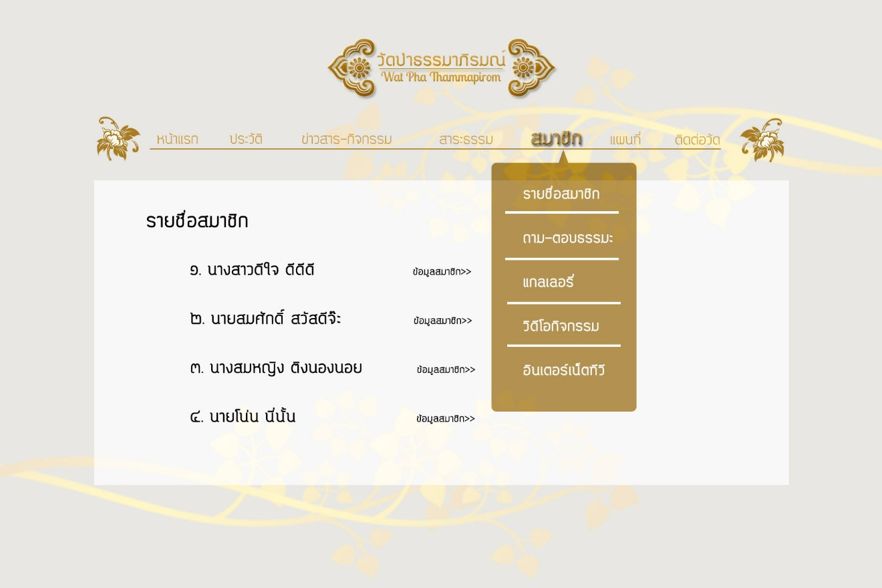

Figure UI-34 : User interface for Member Management page of Administer

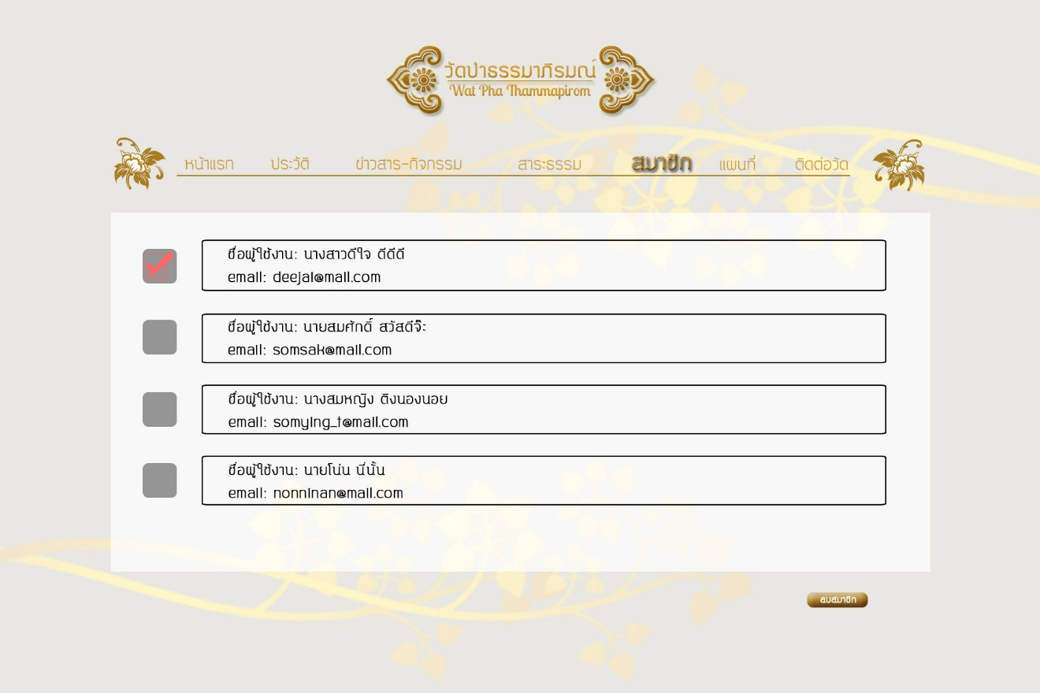

Figure UI-35 : User interface for Delete Member page of Administer

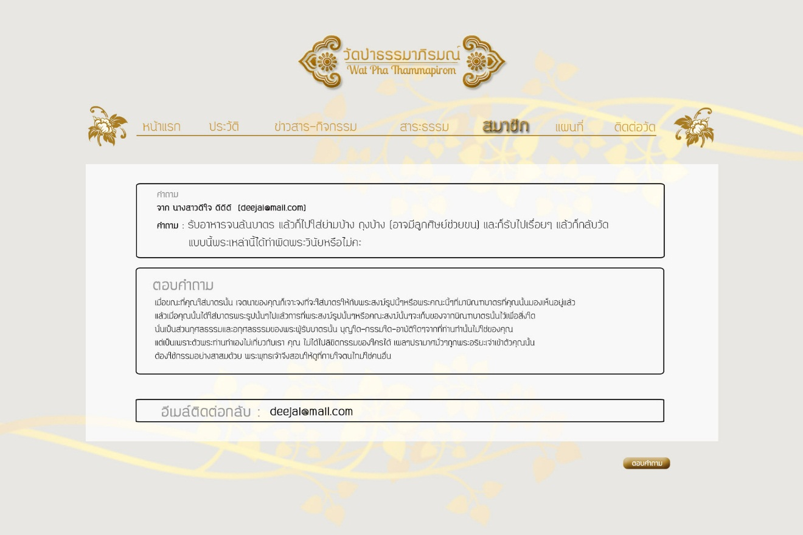

Figure UI-36 : User interface for Dhamma Board Reply page of Administer

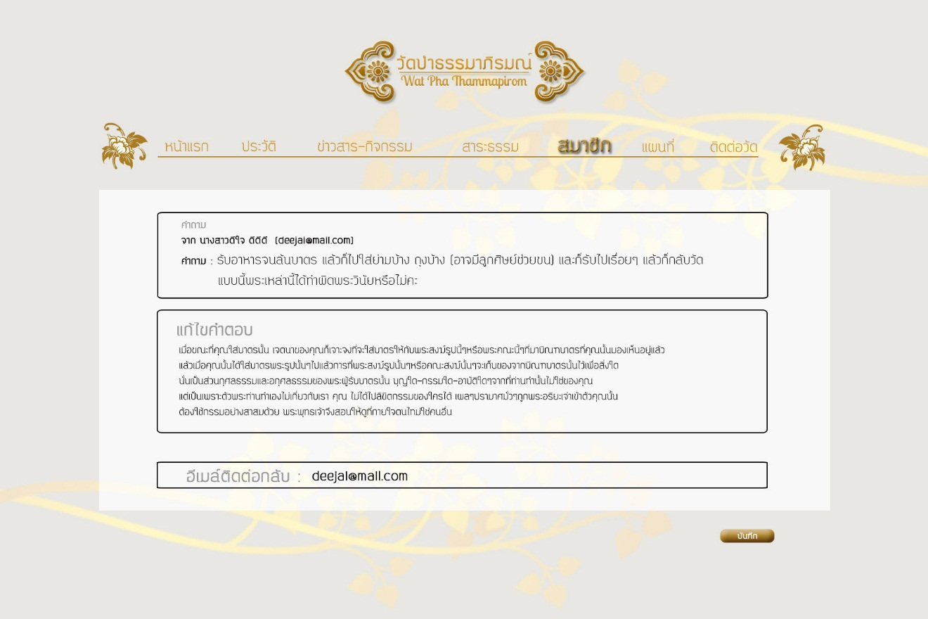

Figure UI-37 : User interface for Edit Dhamma Board Replying page of Administer

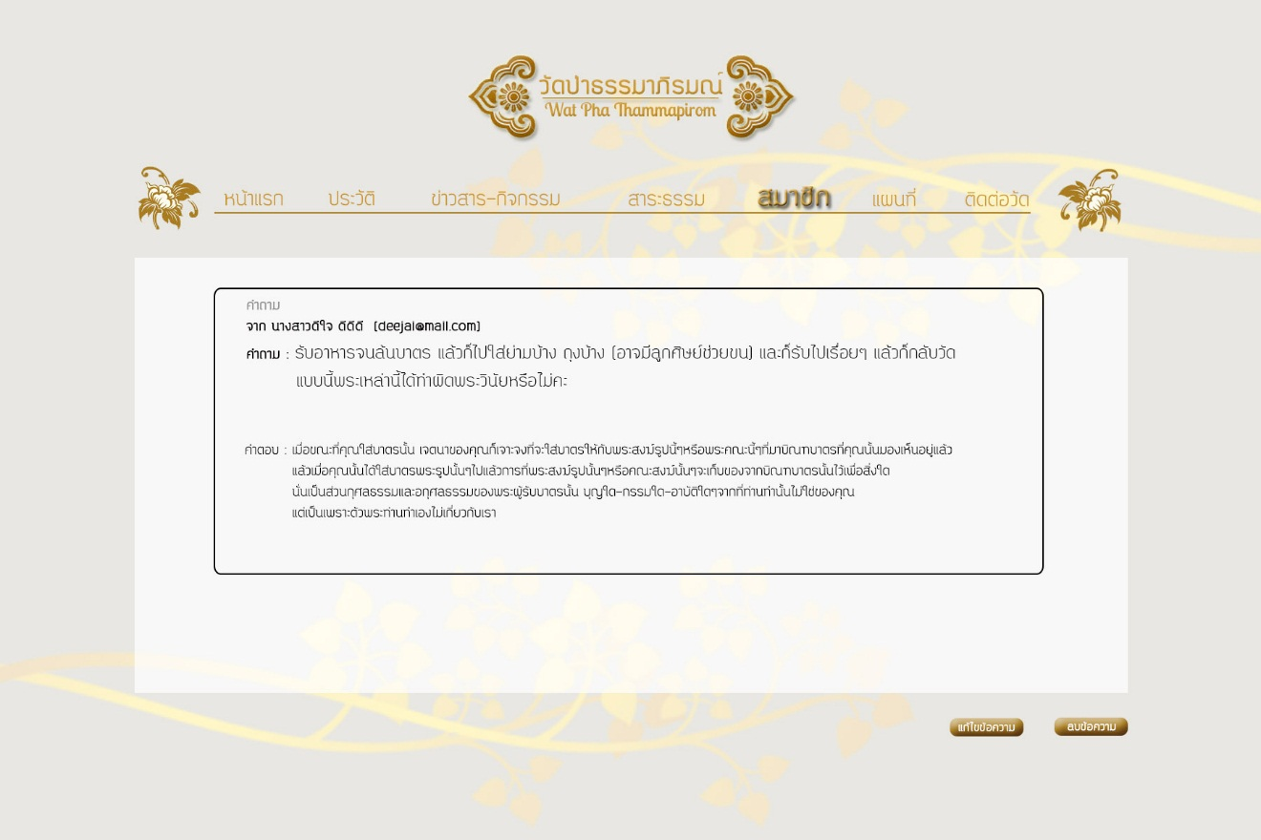

Figure UI-38 : User interface for Dhamma Board page of Administer

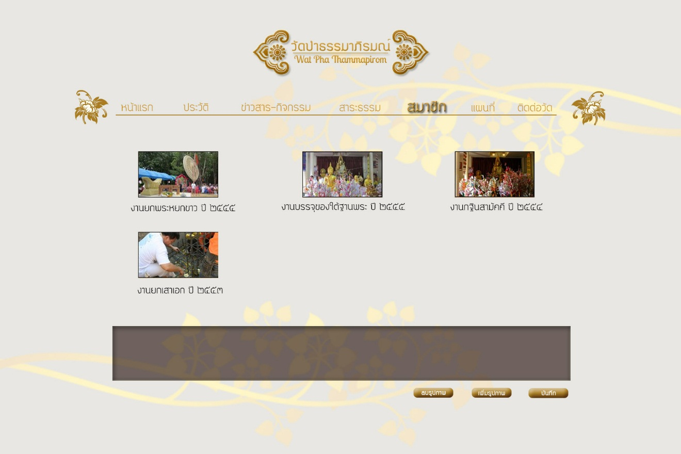

Figure UI-39 : User interface for Gallery page of Administer

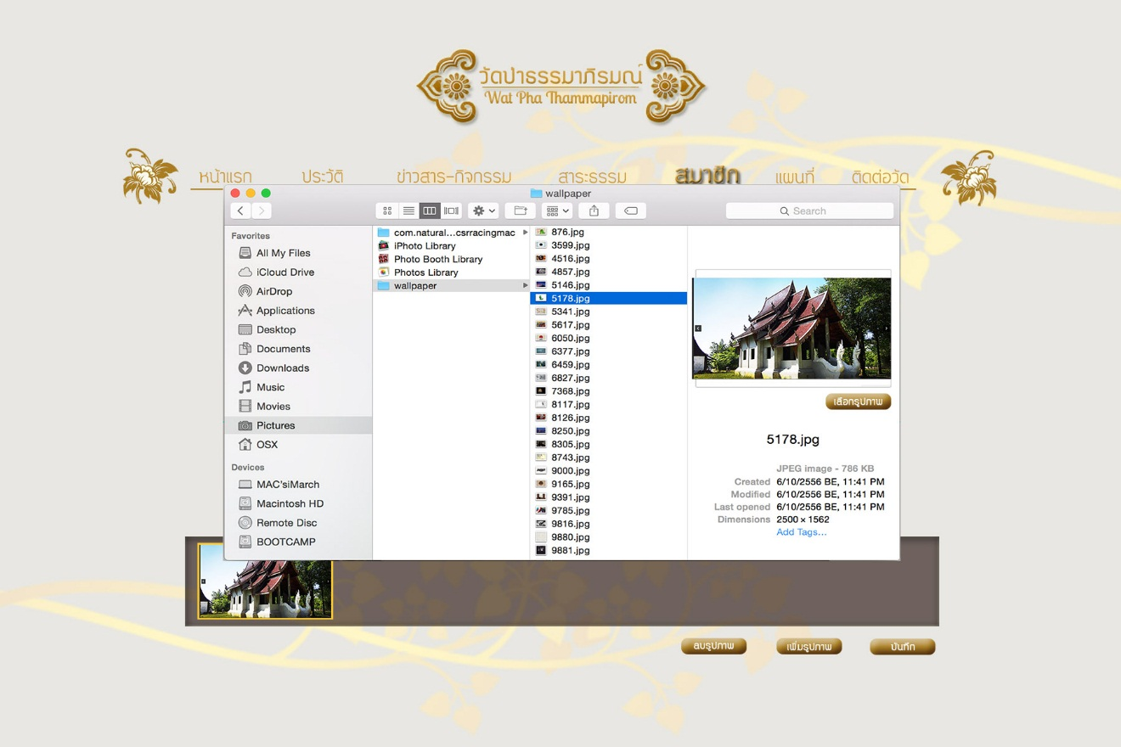

Figure UI-40 : User interface for Add image to Gallery page of Administer

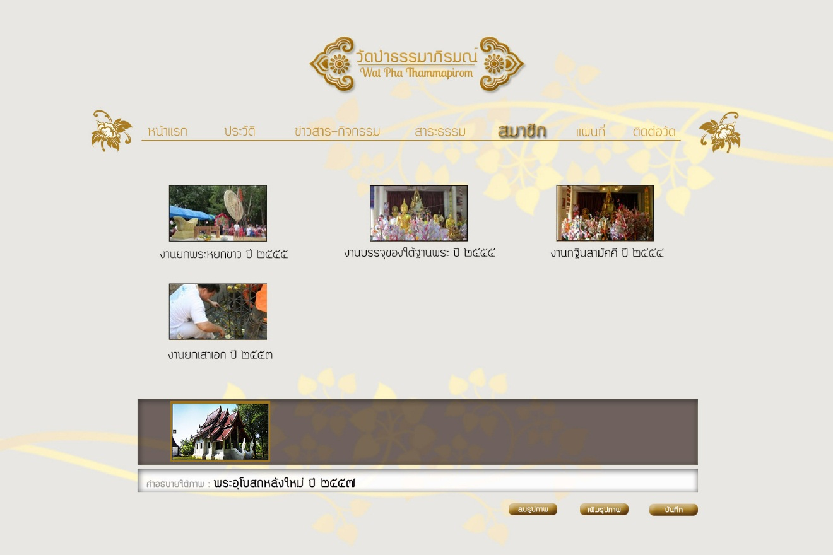

Figure UI-41 : User interface for Add description of image to Gallery page of Administer

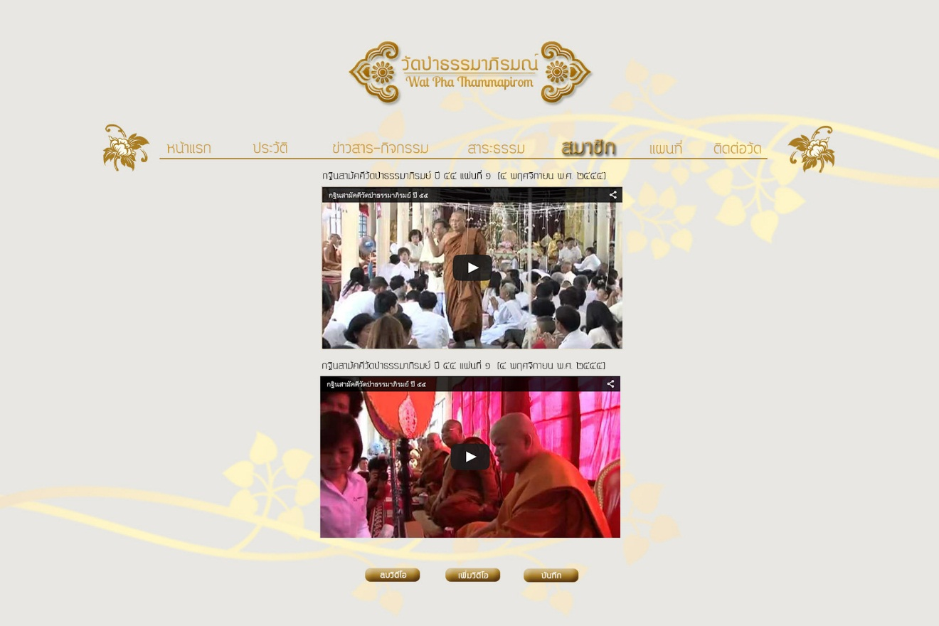

Figure UI-42 : User interface for Activities Video Clips page of Administer

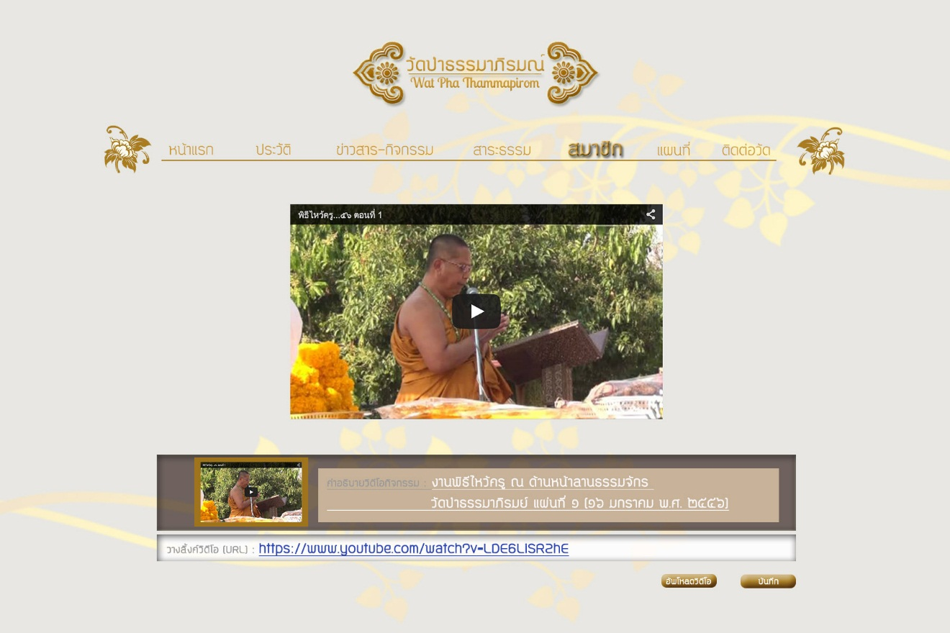

Figure UI-43 : User interface for Add new Activities Video Clips page of Administer

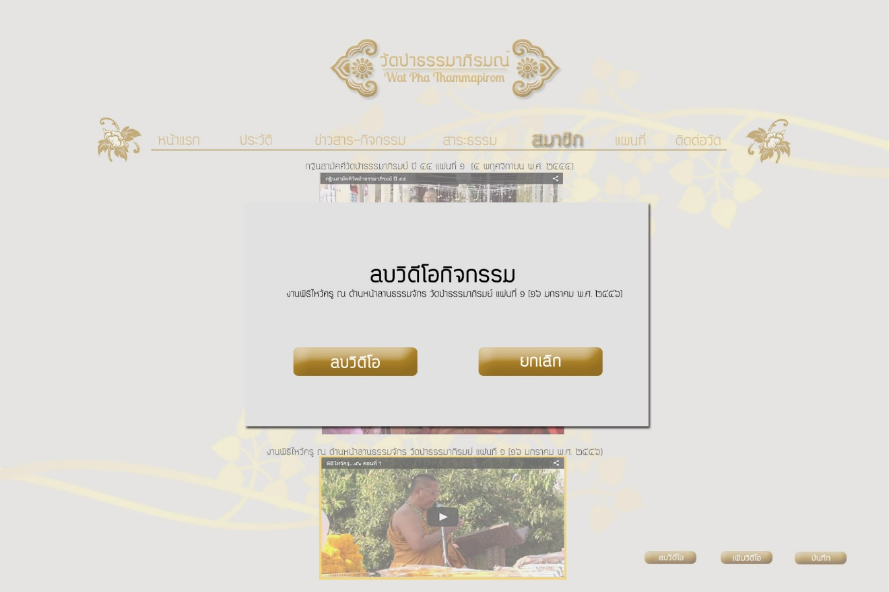

Figure UI-44 : User interface for Delete Activities Video Clips page of Administer

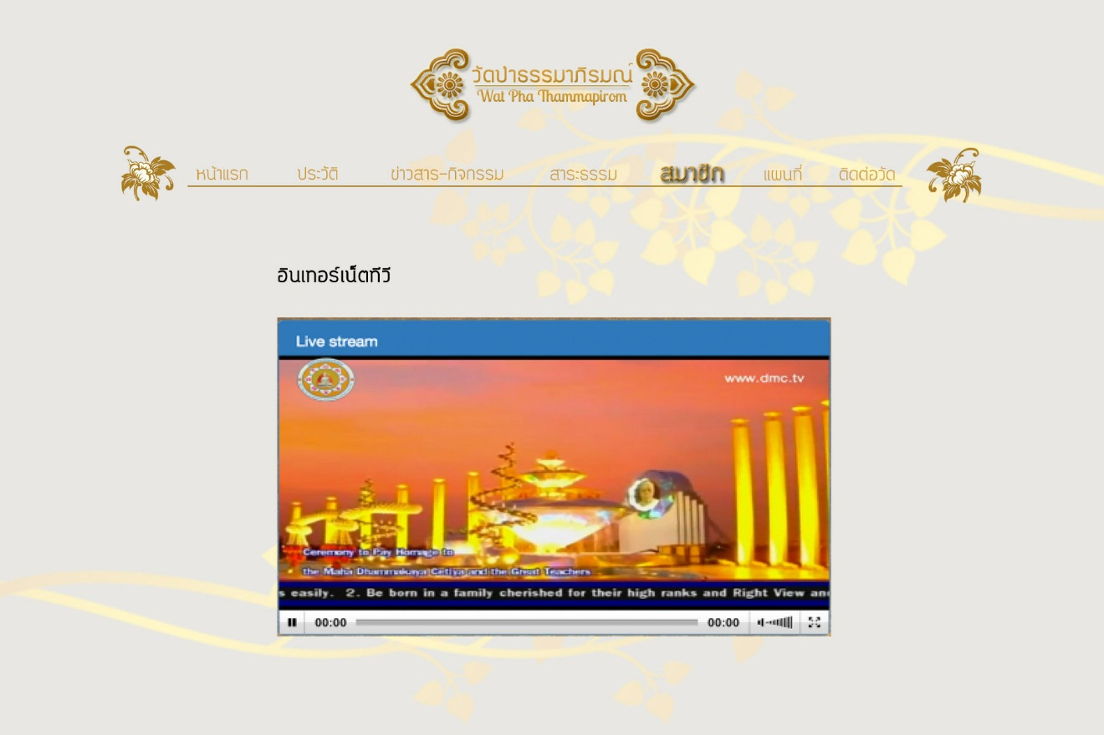

Figure UI-45 : User interface for Internet TV page of Administer

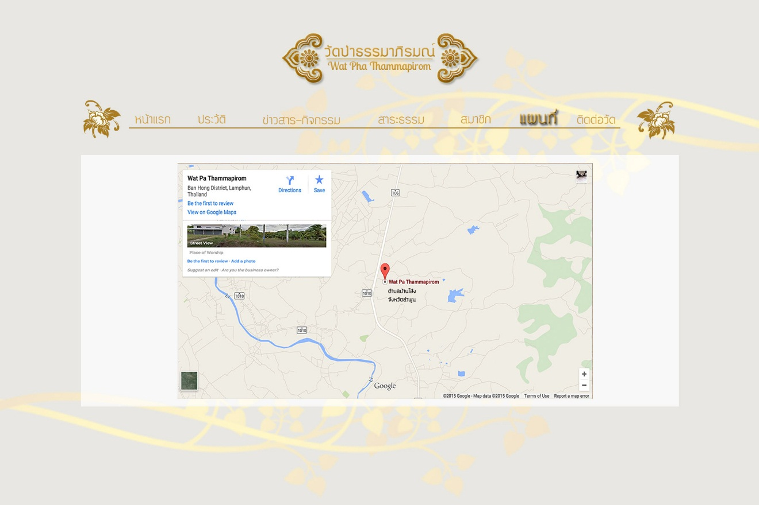

Figure UI-46 : User interface for Temple Map page of Administer

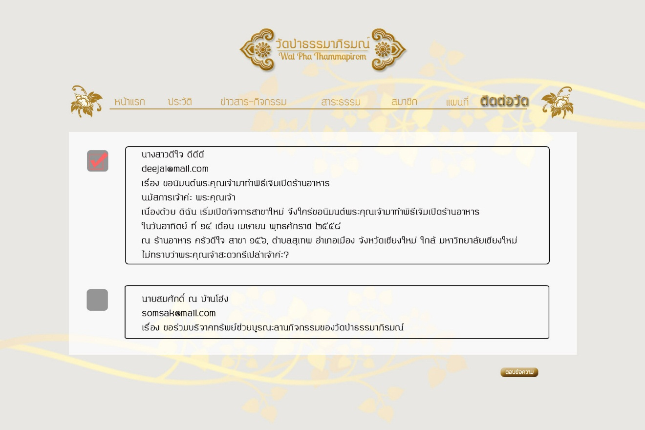

Figure UI-47 : User interface for Temple Contact page of Administer

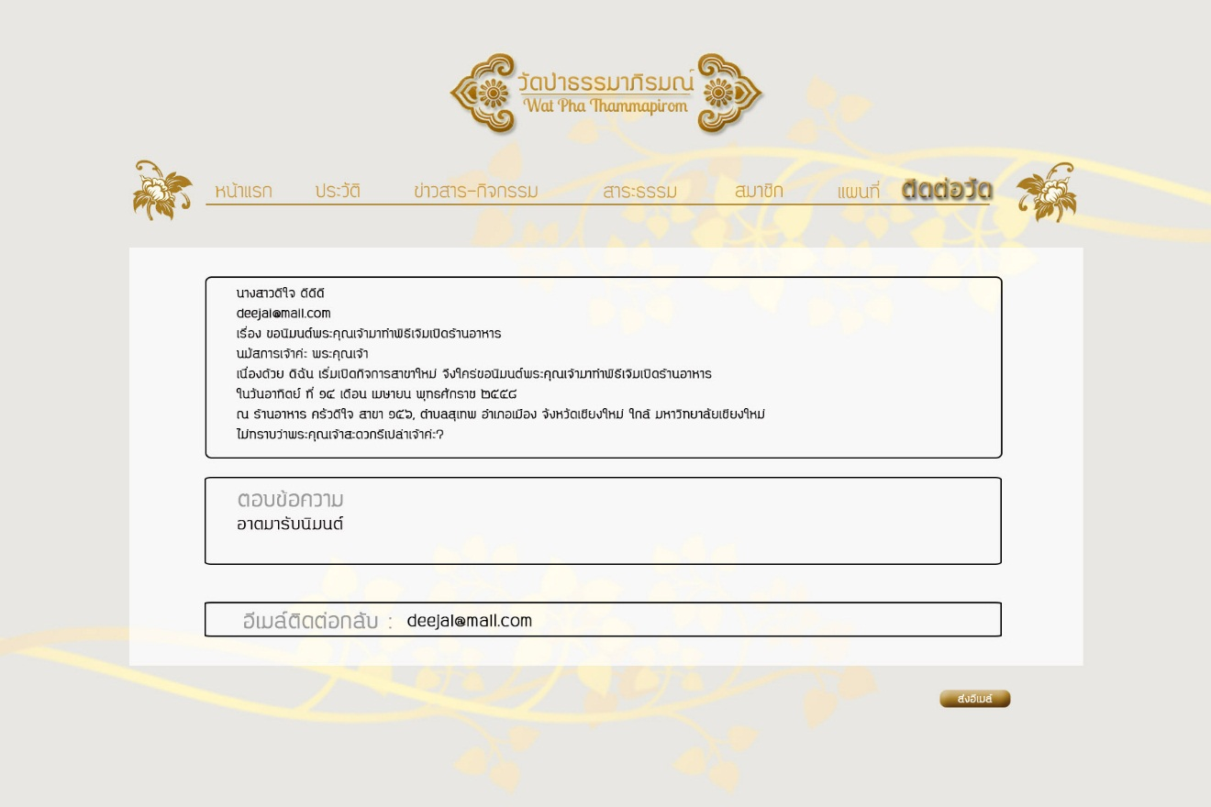

Figure UI-48 : User interface for Send E-Mail Temple Contact page of Administer